Part 2 — The destination · Publisher teardown
Publisher teardown · Part 2 of 2 · The destination app

The destination: a front door for Publisher
The Console is where you build. The destination is where everyone else arrives. It shows the governed content a workspace already has, the insights AI drafts from it, and the answers chat finds, and saving any of them writes it back into the package it came from.
Noah · product + design engineering update · draft, Sep 30, 2026
packages/destination, an uncommitted prototype · screenshots from the destination on :5180 over Publisher on :4000
TL;DR
- The Library starts full. Every dashboard, notebook, data app and model a package serves is already a Library item on its first open, with nothing to import, next to what people have saved and posted.
- Content flows in both directions. Publish in the Console hands a result to the destination for review. In the destination, Save keeps a finding for you, or writes it into its package as a data app that Publisher compiles first and the Console then shows too.
- AI drafts, people decide. The Studio generates grounded insight candidates on a schedule, and a person features or dismisses each one before it reaches For you. Chat answers carry their Malloy, a confidence level, and a source line.
- Each workspace can look like its owner. It has its own name, logo, package scope and theme. Every token, including the chart palette, is re-derived for light and dark, and embedded Publisher content receives the same tokens.
- Next: the recommendation loop. What people read, save, dismiss and follow steers what the Studio looks for next, and the Studio goes from finding facts in a model to proposing additions to it.

01 What the destination is
A separate app in the same repo, built for readers rather than modelers, that sits on top of the Publisher REST API.
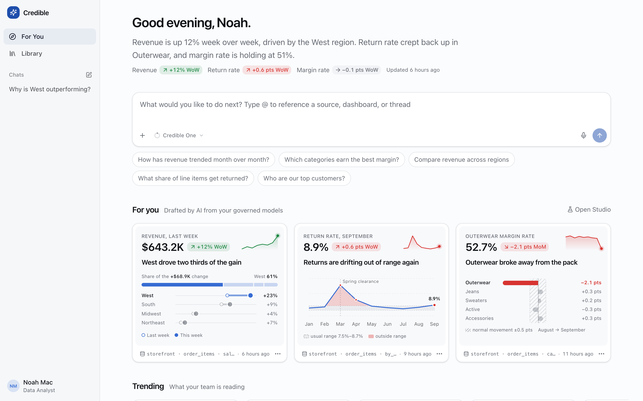
For You, the home page. A briefing written from this week's numbers, with its KPI deltas inline. Below it are the composer, suggested questions, and three AI-drafted cards, each with a chart designed for its point and a package · source · view line naming where it came from. /
Surface | Route | What it's for
For You | / | The briefing, AI-drafted insight cards, what's trending, and where you left off
Library | /library | Personal and workspace scopes; everything packages serve plus everything people keep
Chats | /chat/:id | Threads with the analyst; every answer is grounded and can be saved
Analysis | /analysis/:id | One finding: narrative, evidence, query, rows, comments, and related content
Studio | /studio | Generate, inspect, feature, dismiss, and schedule insights
Publish | /publish#draft=… | Review a result handed over from the Console before anyone sees it
Package pages | /packages/:pkg/{dashboards,models,notebooks,apps}/… | Publisher content rendered inside the shell, with details and relations
Stack. React 19, Vite, Tailwind and shadcn/Radix for the shell, and the Publisher SDK for embedded dashboards, models, notebooks and data apps. The analyst runs as a Cloudflare Worker at /api/analyst/*, served through Vite in development. It has two stages. An explorer uses four tools (list_sources, describe_source, run_query, compute_metric) and returns findings. A presenter, with no tools, turns those findings into a report spec. The same tools are exposed over MCP as credible-analyst, so an outside agent explores with the same allowlist and query guard. Library state (items, threads, comments, collections) is fixture data in localStorage for now. Publisher content is read live.

02 The workspace Library, full on day one
A Library that starts empty doesn't get used. This one starts with everything the workspace's packages already serve.
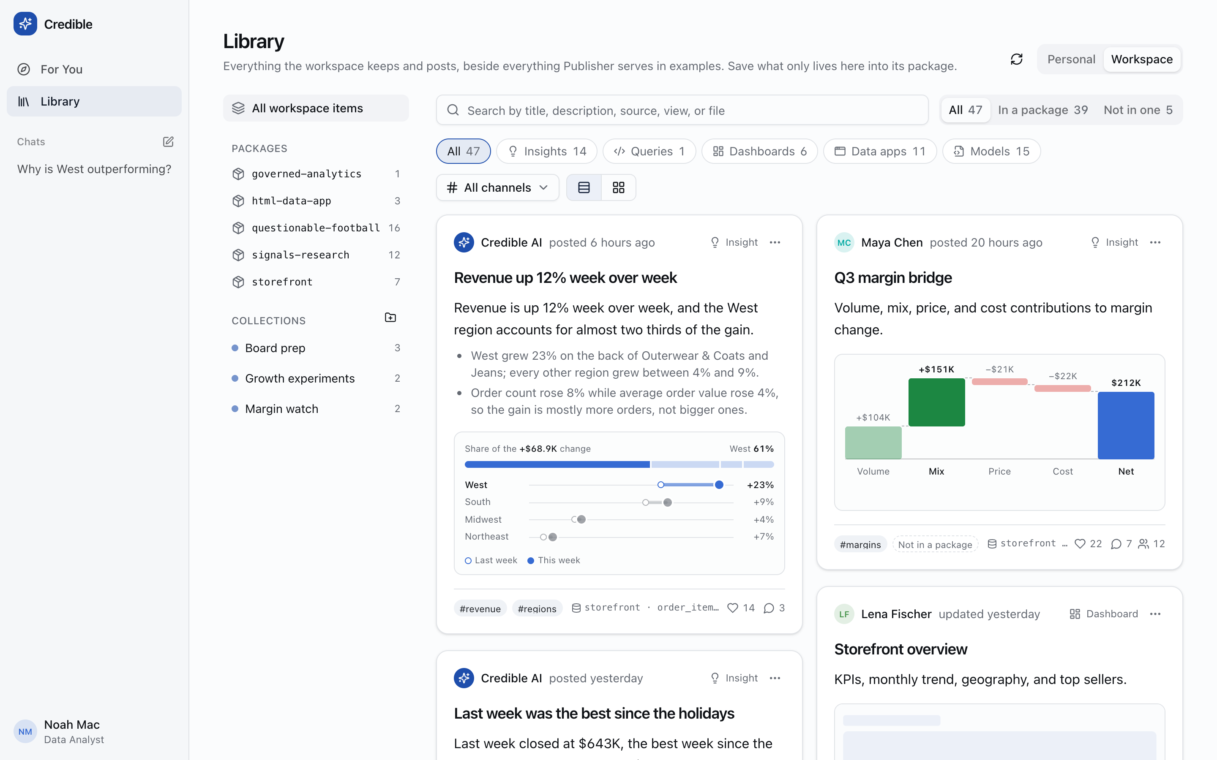
Workspace scope. Posts from people and from Credible AI sit beside the package's own content: 47 items, 39 of them in a package. The left rail lists packages (with counts read from Publisher) and collections. The filters split items by kind, by channel, and by whether they live in a package or only here. /library?scope=workspace
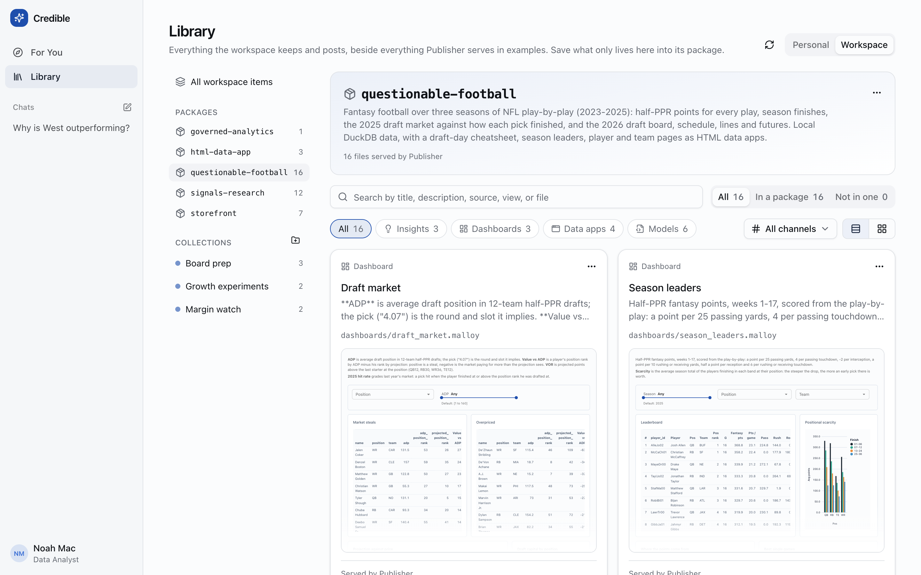
One package, as Library content. Picking questionable-football shows its publisher.json description and its 16 files: three dashboards with live thumbnails, the notebook, four HTML pages, two saved findings, and six models. Each one is "In a package"; nobody had to post it. /library?package=questionable-football
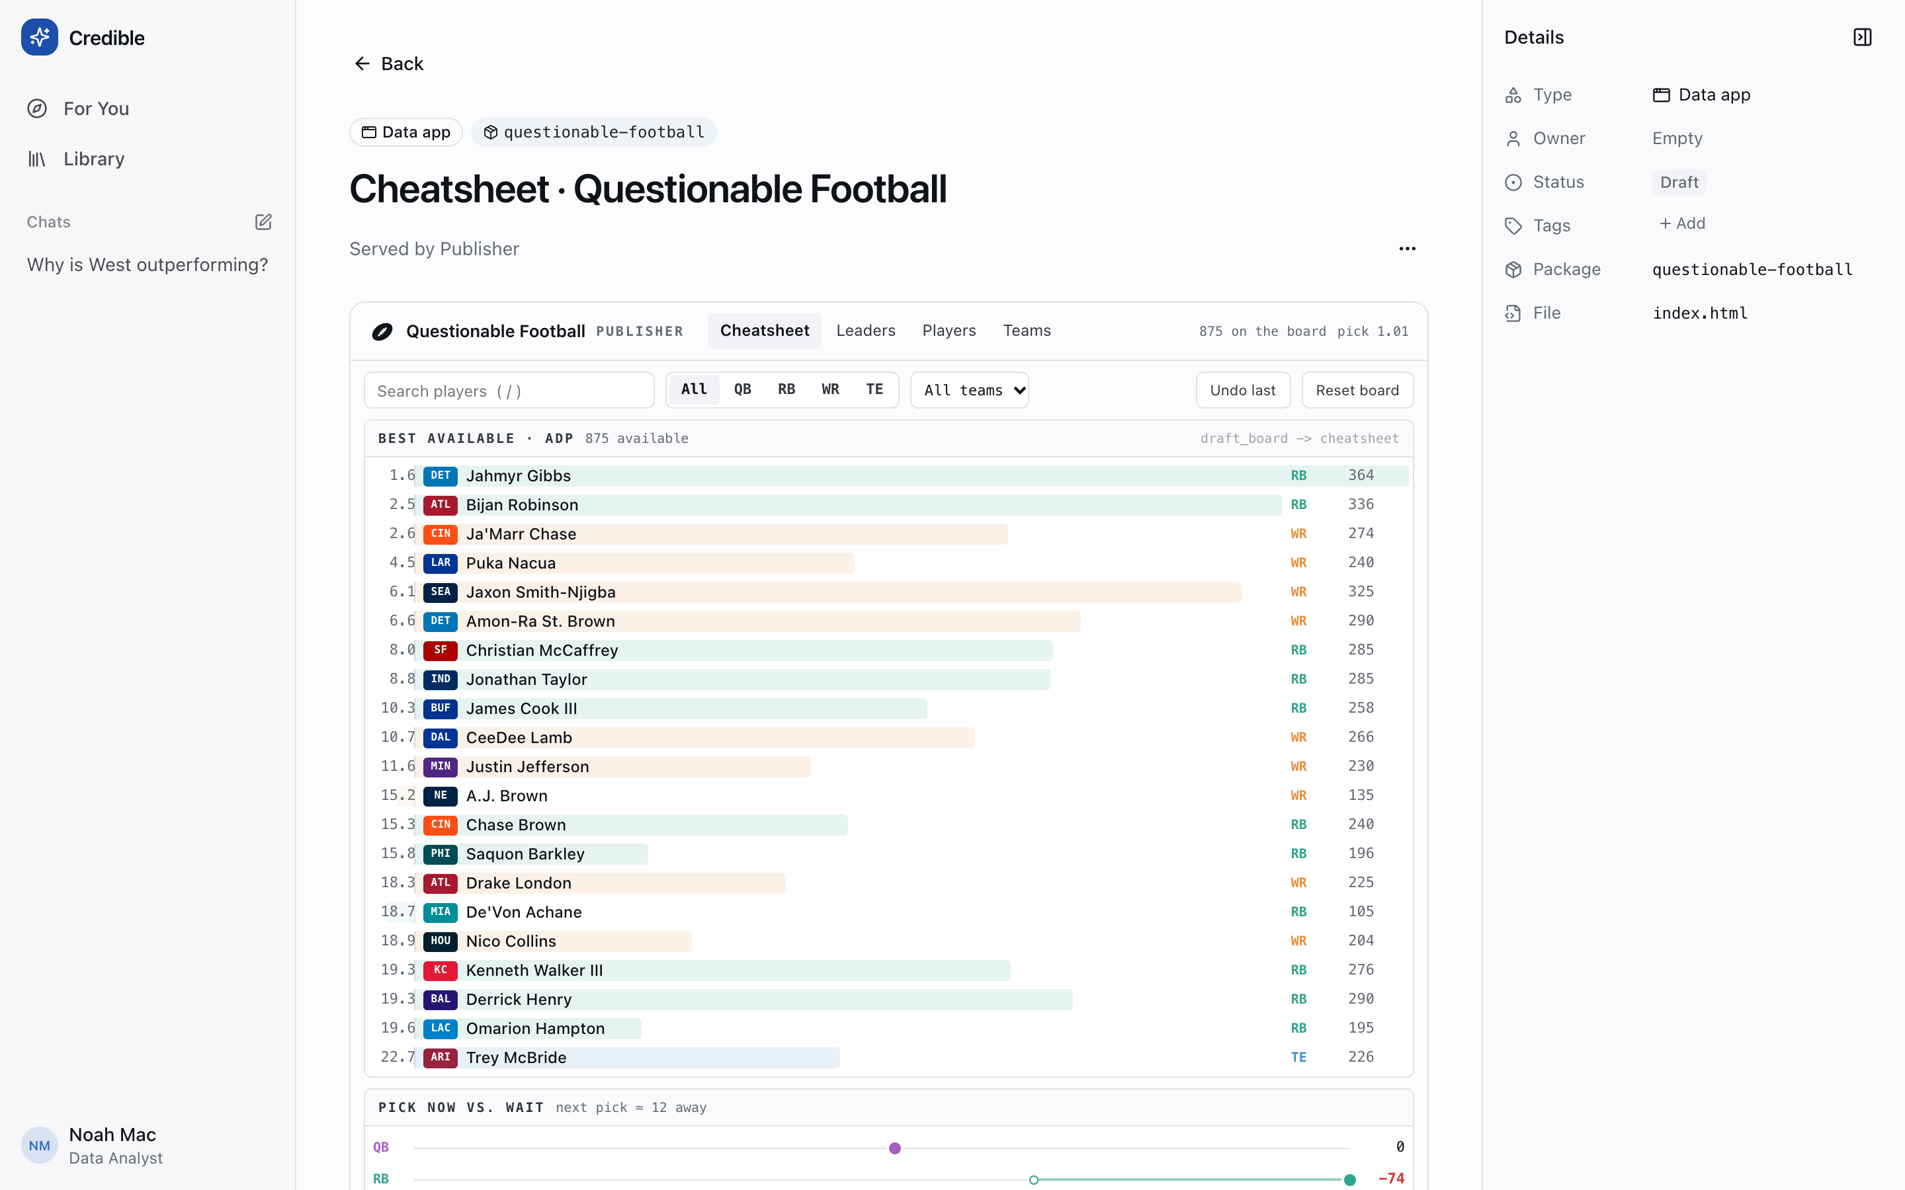
A hand-written data app, embedded. The Cheatsheet from Part 1 runs unmodified inside the shell, with a details rail and comments that Publisher itself has no place for.
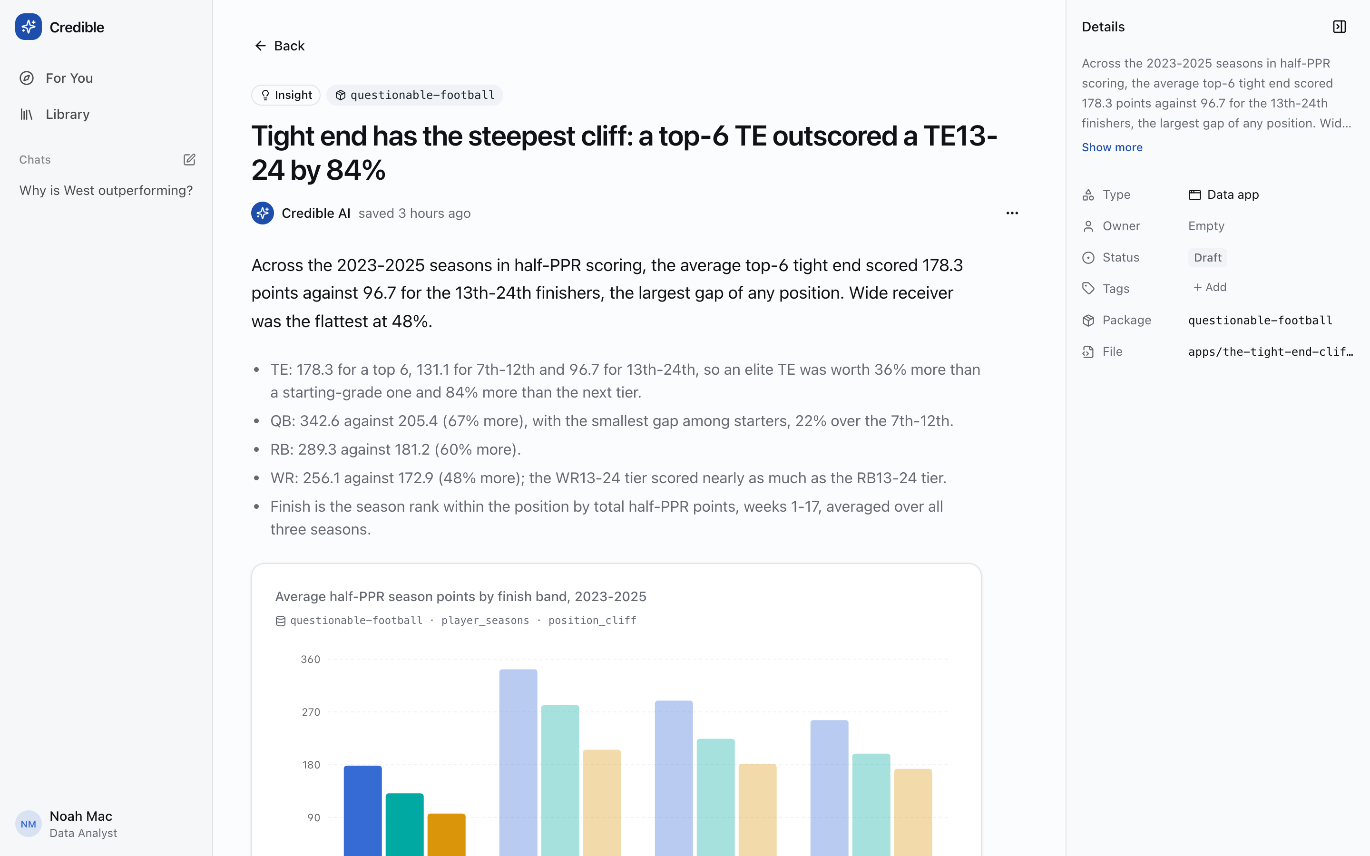
A saved finding, rendered natively. The app.json manifest is read and drawn with the destination's own components rather than in an iframe, so it gets the workspace theme, a package · source · view line, and comments.
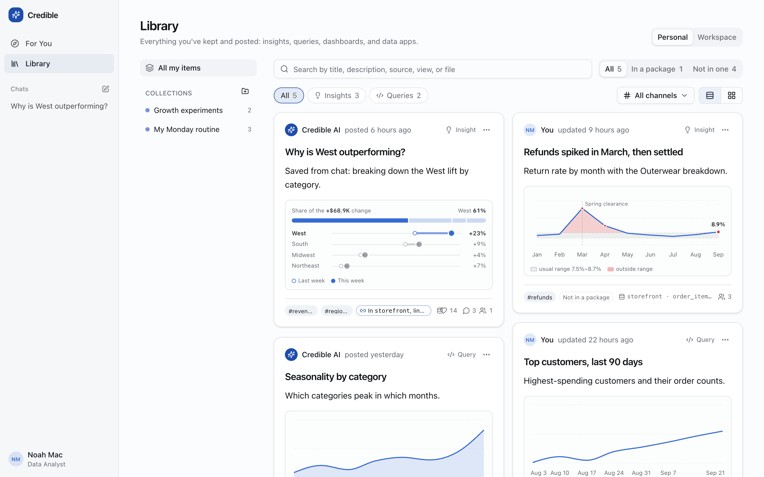
Personal scope. What you've kept: things saved from chat, your own queries, and your collections. A personal item can link to a package (In storefront) or stay only here (Not in a package), and the card says which.

Relations, not tags
Every page's details rail lists what it's connected to, and the links are read from what the files declare (imports, sources, tile queries, model paths in a data app's page), never guessed from names. On an analysis, that means Depends on storefront.malloy, Also reads order_items (five other analyses), and Referenced in the chat thread that produced it. That graph is what the composer, For you and, later, the recommendation loop all run on.

03 A new entry point: Publish from Publisher
The Console's results used to stay in the Console. Now every query result and every dashboard has a Publish button that hands it to the destination for review.
- Console — Run a query, or open a dashboard
- Publish dialog — Title, description, and what gets sent
- /publish#draft=… — Review before posting
- Where it goes — Into its package for everyone, or kept for you; channels
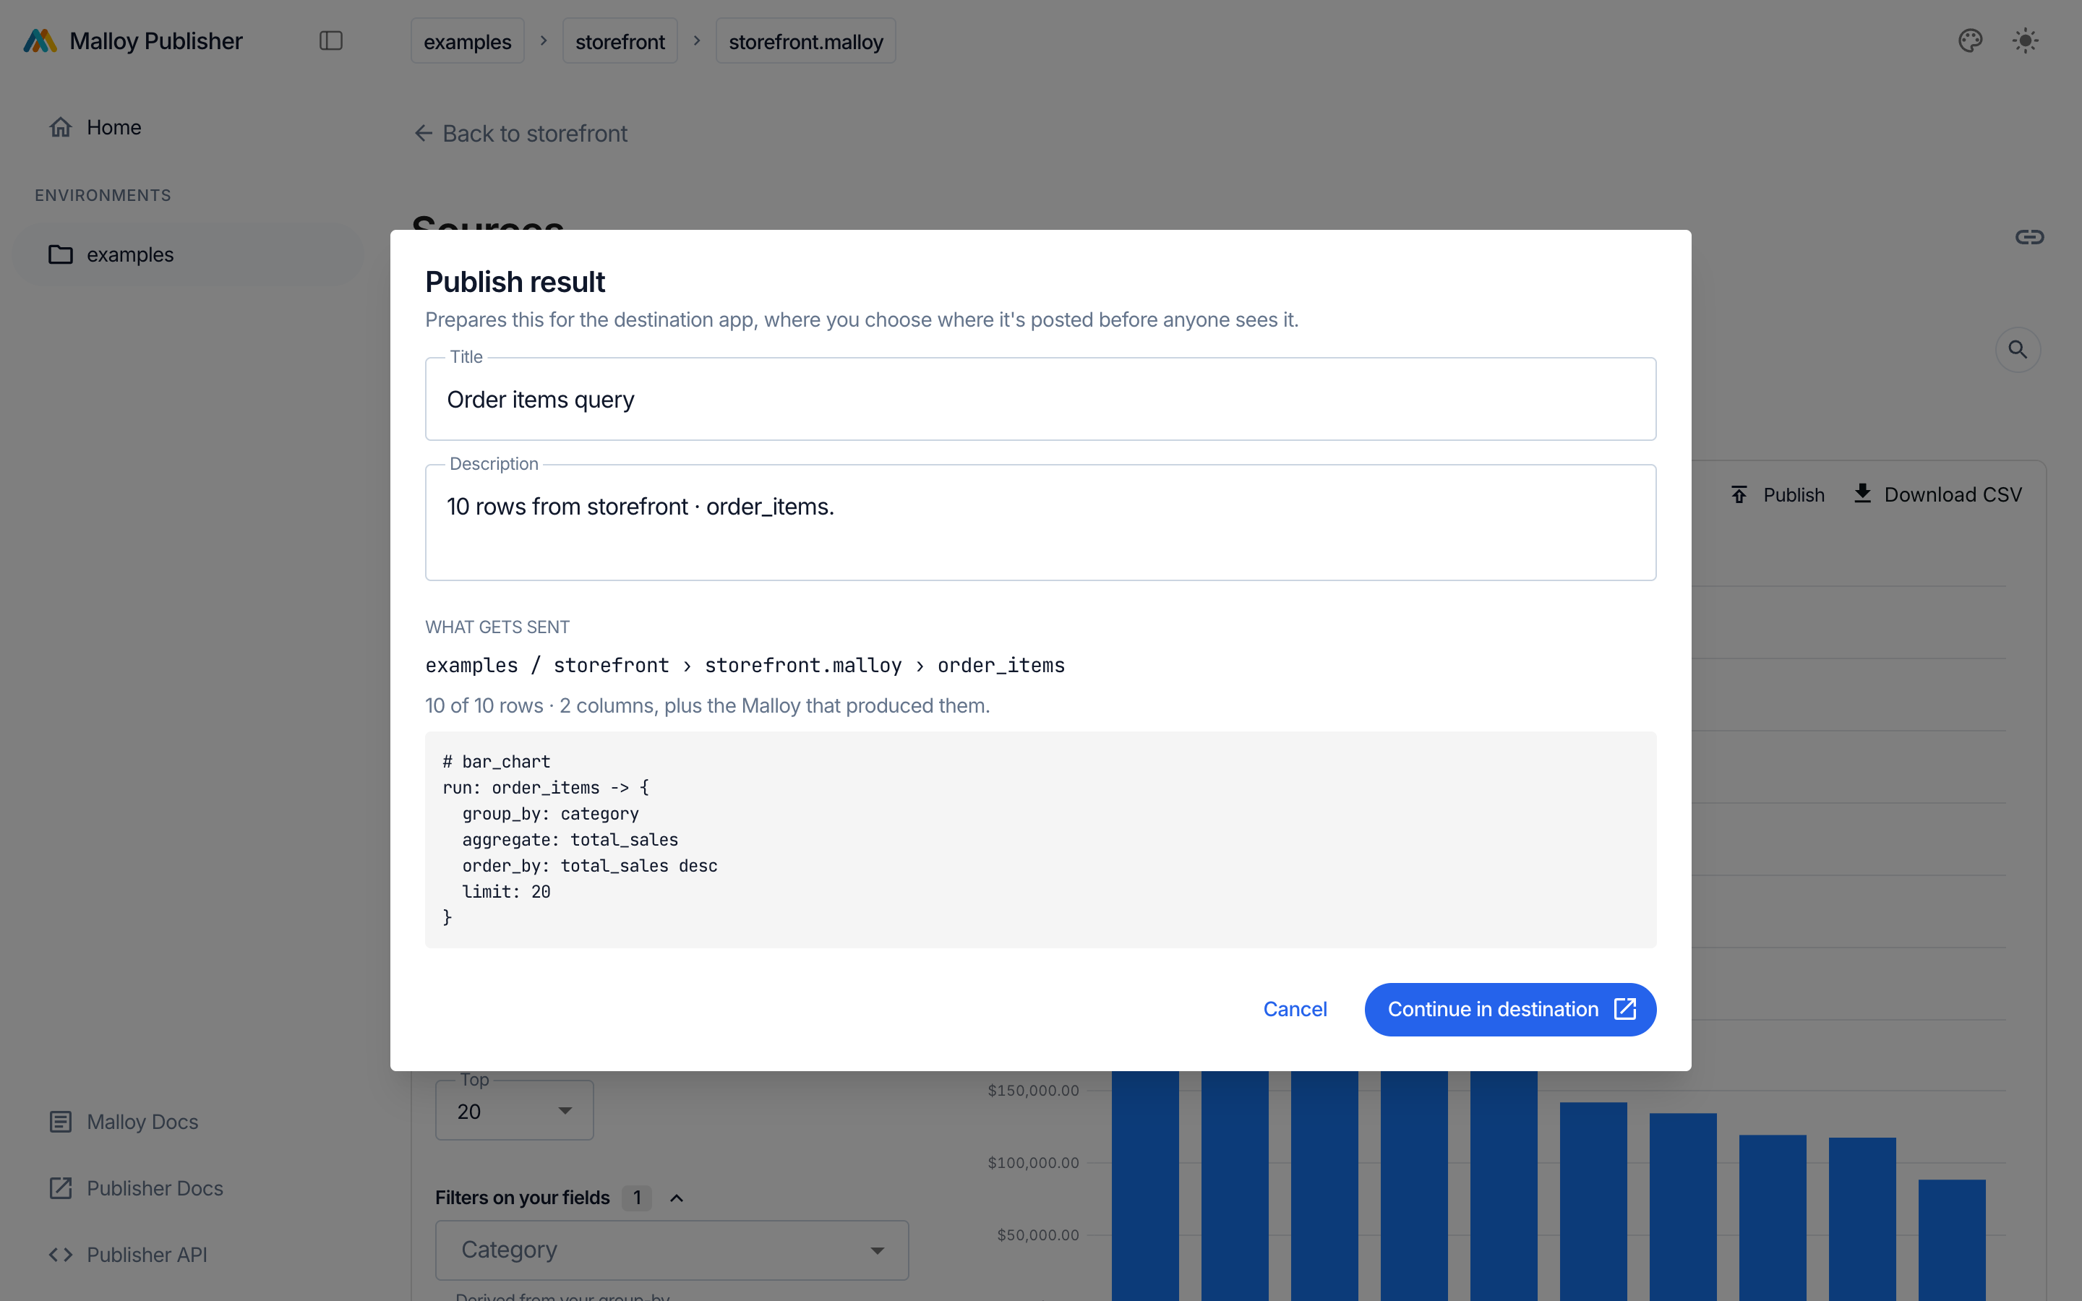
In the Console. The Question-mode result from Part 1, being published. The dialog shows exactly what leaves: examples / storefront › storefront.malloy › order_items, 10 of 10 rows by 2 columns, and the Malloy. A dashboard sends a link with its current filters instead of rows. ConsolePublishProvider.tsx
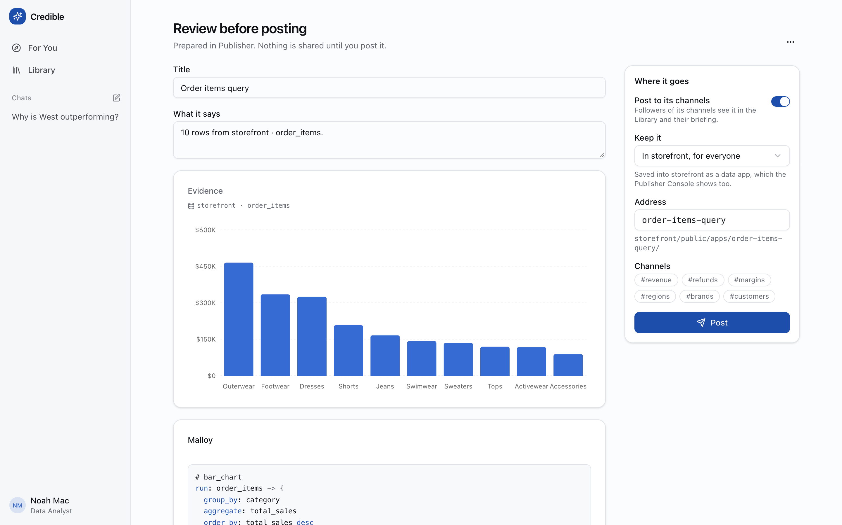
In the destination. Review before posting. Prepared in Publisher. Nothing is shared until you post it. The evidence chart is drawn from the rows (first text or date column on the axis, up to four numeric series), the Malloy comes along with it, and Where it goes chooses a scope, an address under storefront/public/apps/, and channels. /publish
Why a URL fragment. The draft travels as base64url JSON in #draft=…. The fragment never reaches a server, so nothing is stored anywhere until a person presses Post. The shape is versioned (version: 1) and declared on both sides: destinationDraft.ts in the Console and handoff.ts in the destination. A link from a newer Publisher fails with a sentence, not a stack trace. The Console only shows Publish when a destination is configured (VITE_DESTINATION_URL, or :5180 in development).

04 For you, and the Studio behind it
For you shows only what a person has chosen to feature. The Studio is where AI-drafted insights are generated and wait for that choice.
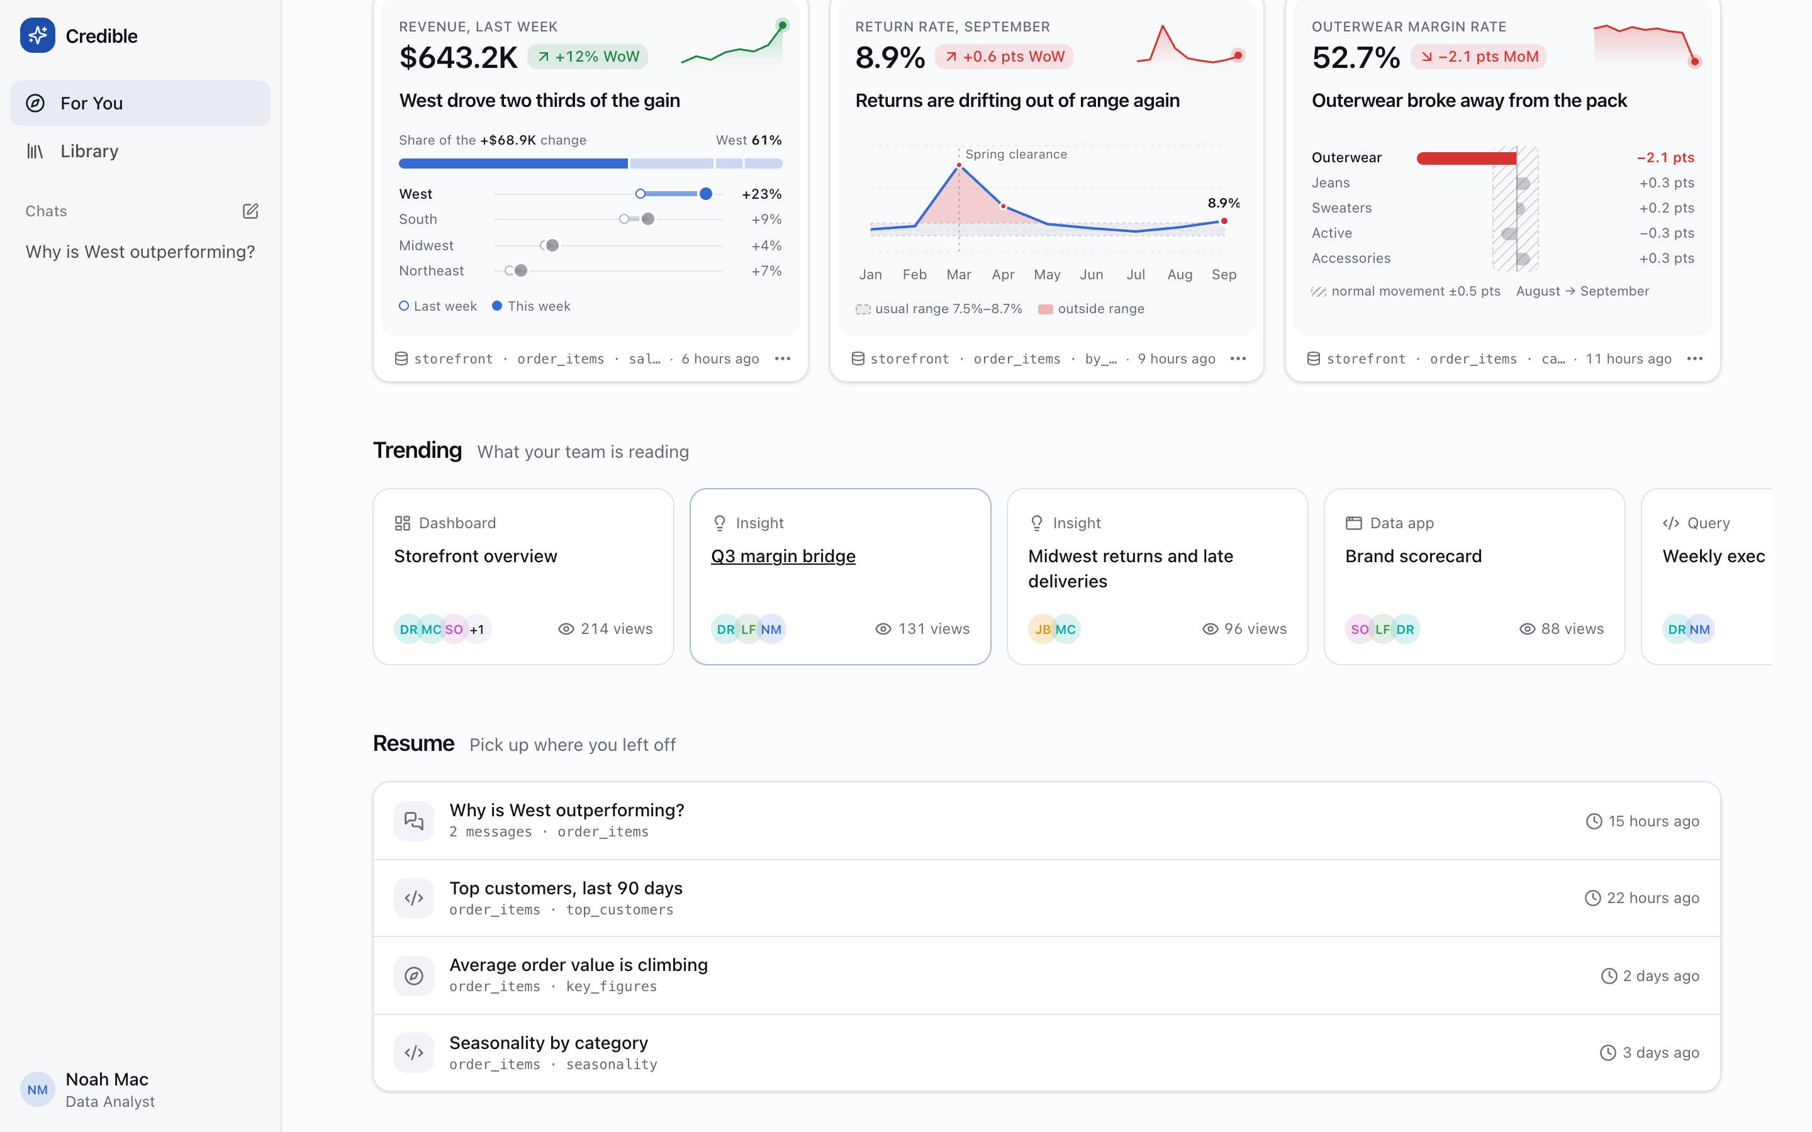
Below the fold. Trending is what the team is reading, with view counts and readers' avatars, across every content kind. Resume lists threads and queries you left open, with the source each one reads.
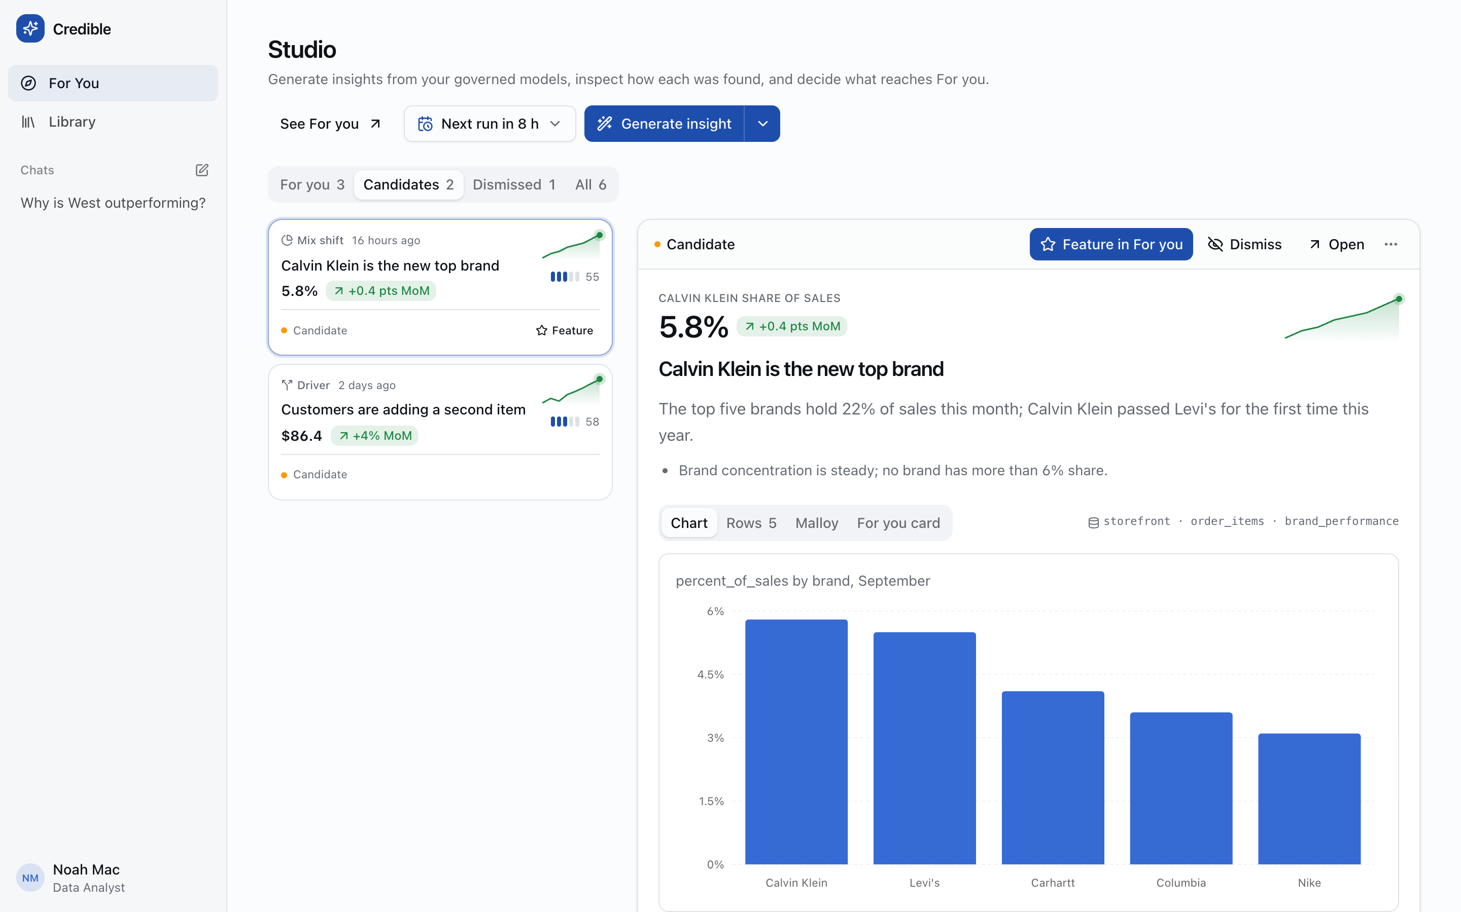
The Studio. Candidates on the left, each with its detector (Mix shift, Driver), a score, and a sparkline. On the right is the inspector, where you check a candidate before featuring it: the chart, the rows behind it, the Malloy, and a preview of its For you card. /studio
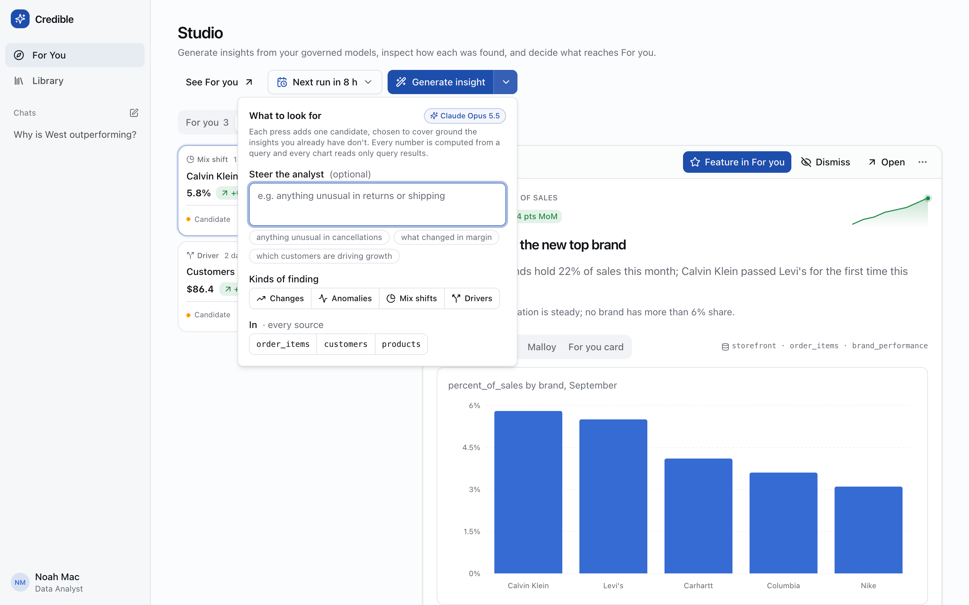
One press, one new insight. Each press is chosen to cover what the existing insights don't. You can steer it in plain words ("anything unusual in returns"), limit it to kinds of finding (changes, anomalies, mix shifts, drivers), and limit it to sources.
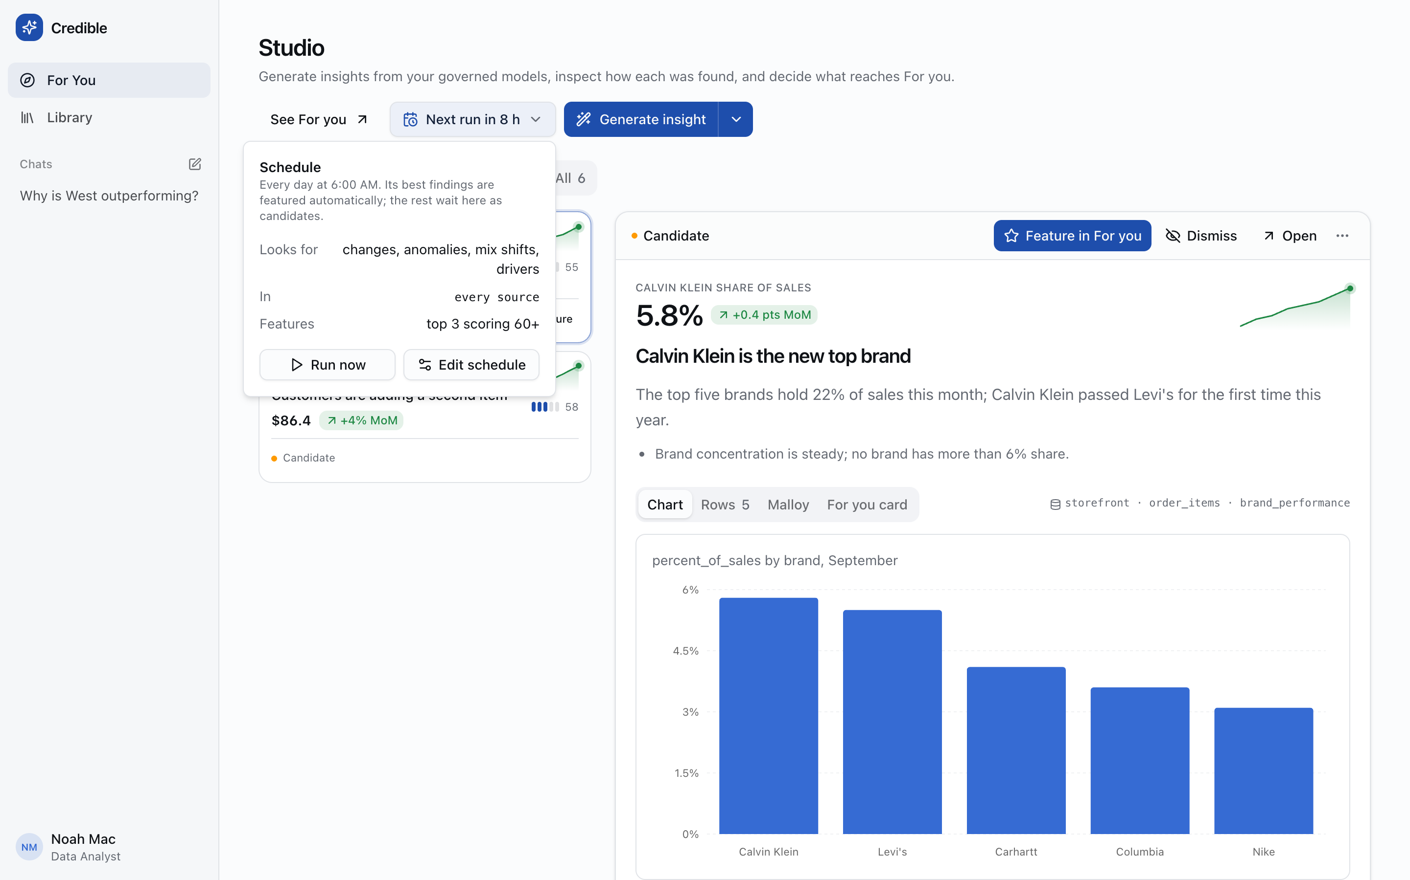
On a schedule. Every day at 6:00 AM: look for all four kinds of finding in every source, feature the top 3 scoring 60 or more automatically, and leave the rest waiting as candidates.

Nothing is kept on trust
Generation runs Claude Opus 5.5 over the analyst's tools. Each draft must pass two checks. Every number in it must be a metric computed by compute_metric from a query result, and every chart must read only this run's datasets and render headless. A draft that fails gets one repair turn, then it's dropped, and a thin run lists what it threw out. Without an API key, a scripted planner stands in, so the Studio still works offline.

Reading suggests what to read next
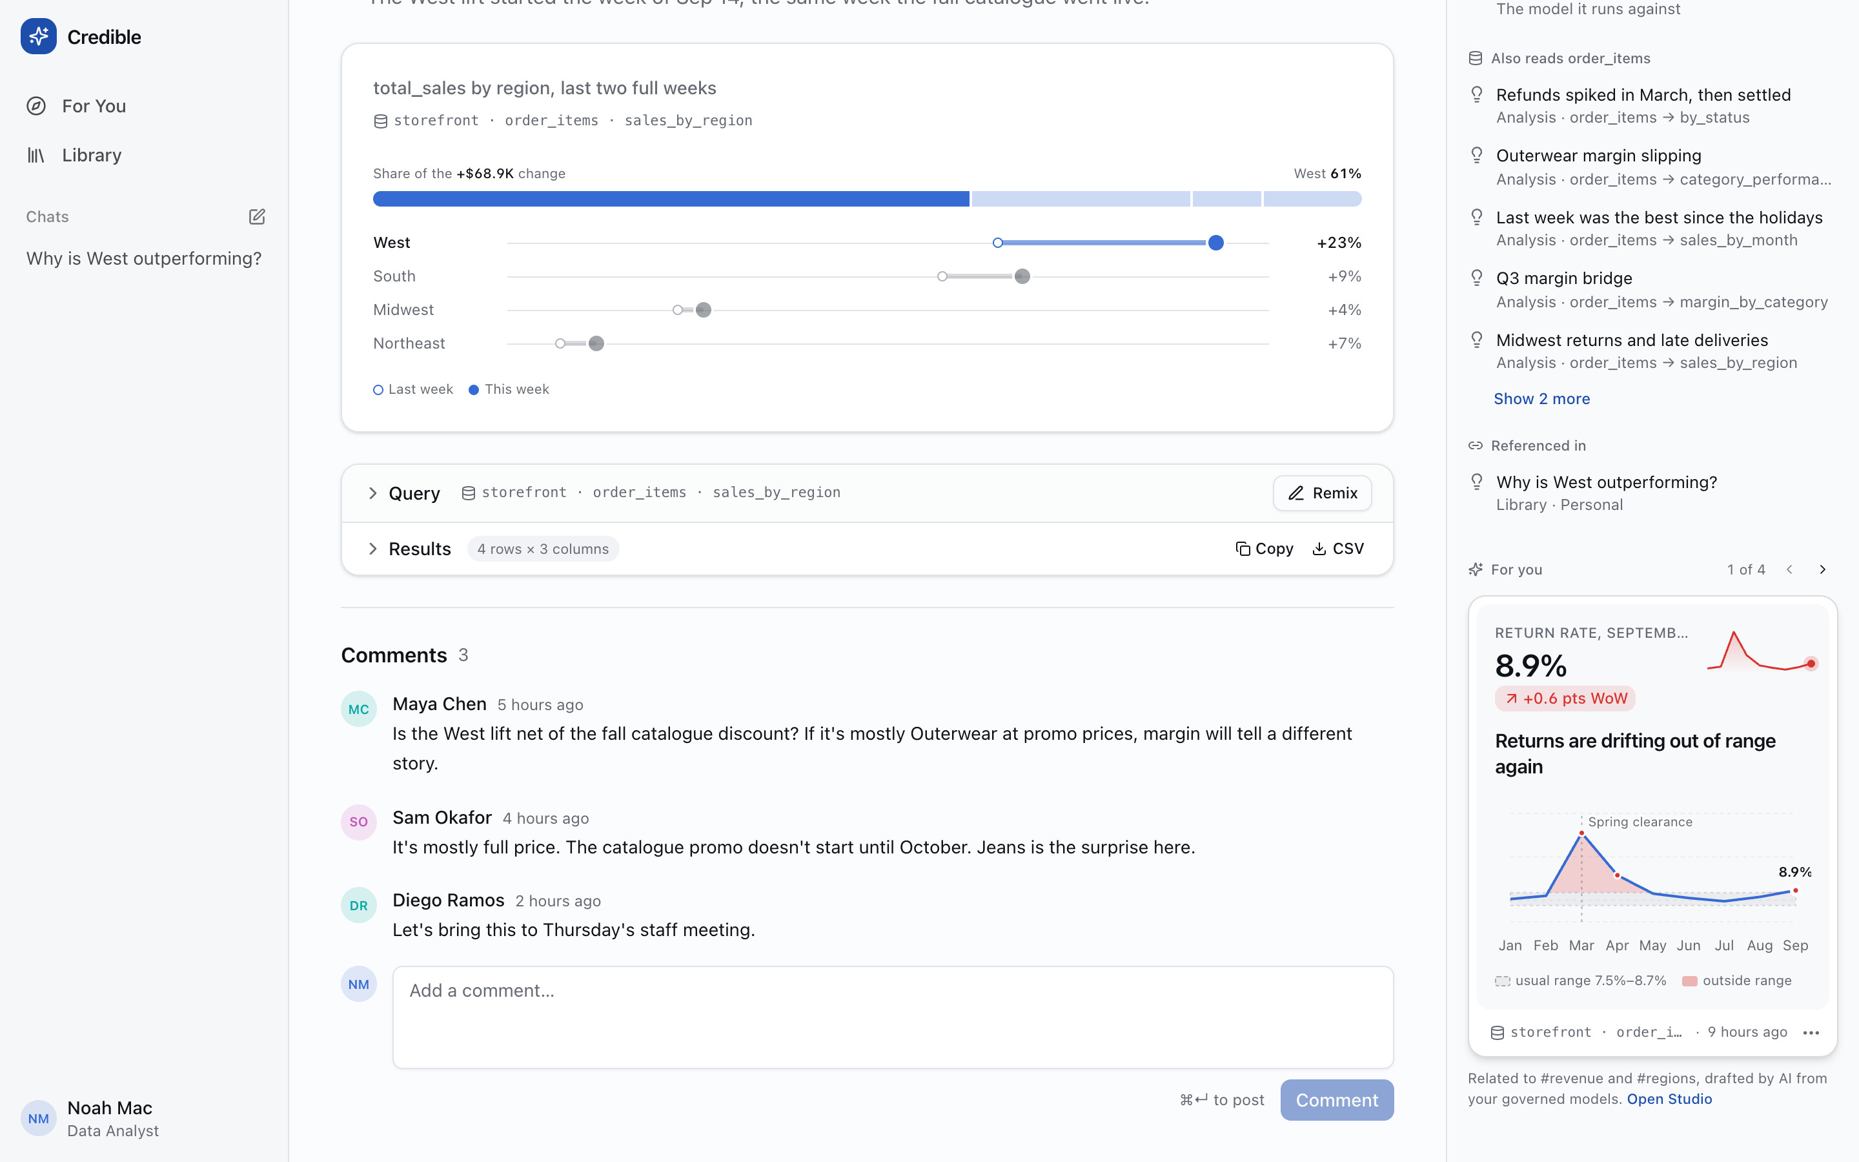
For you, on every analysis. At the bottom of the details rail, one card at a time: Related to #revenue and #regions. Paging past the last card asks the Studio for more like this one, and what it finds becomes the next page.
The ranking is deliberately simple and readable today. An insight's own score, plus 0.25 per topic it shares with what you're reading, 0.1 for the same source, 0.15 for the same view, and 0.1 if a person featured it. Insights you've opened this session drop behind ones you haven't. Dismissing one says "You'll see fewer insights like this," with an undo. §08 is about making that sentence true across sessions.

05 Chat, and saving what it finds
An answer in chat is a draft finding. One click keeps it for you, and a second puts it in the package for everyone.
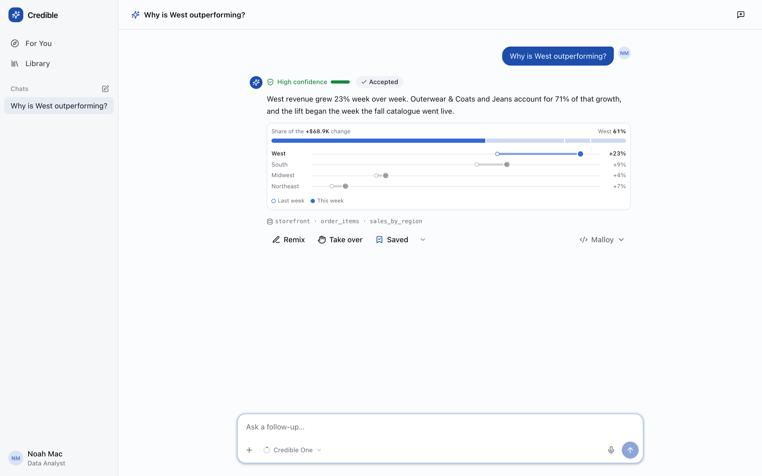
A grounded answer. Why is West outperforming? The answer gives a confidence level and a status (Accepted), a chart with its source line (storefront · order_items · sales_by_region), and the actions: Remix (edit the query), Take over (continue it yourself), Save, and the Malloy. Admins also get Show work, the full tool trace. /chat/th-west
- Chat answer — A draft; nothing kept yet
- Save for me — An analysis in your Library
- Save to storefront… — A data app at public/apps/<slug>/
- Also add its query — Optional: a view: or query: in the model
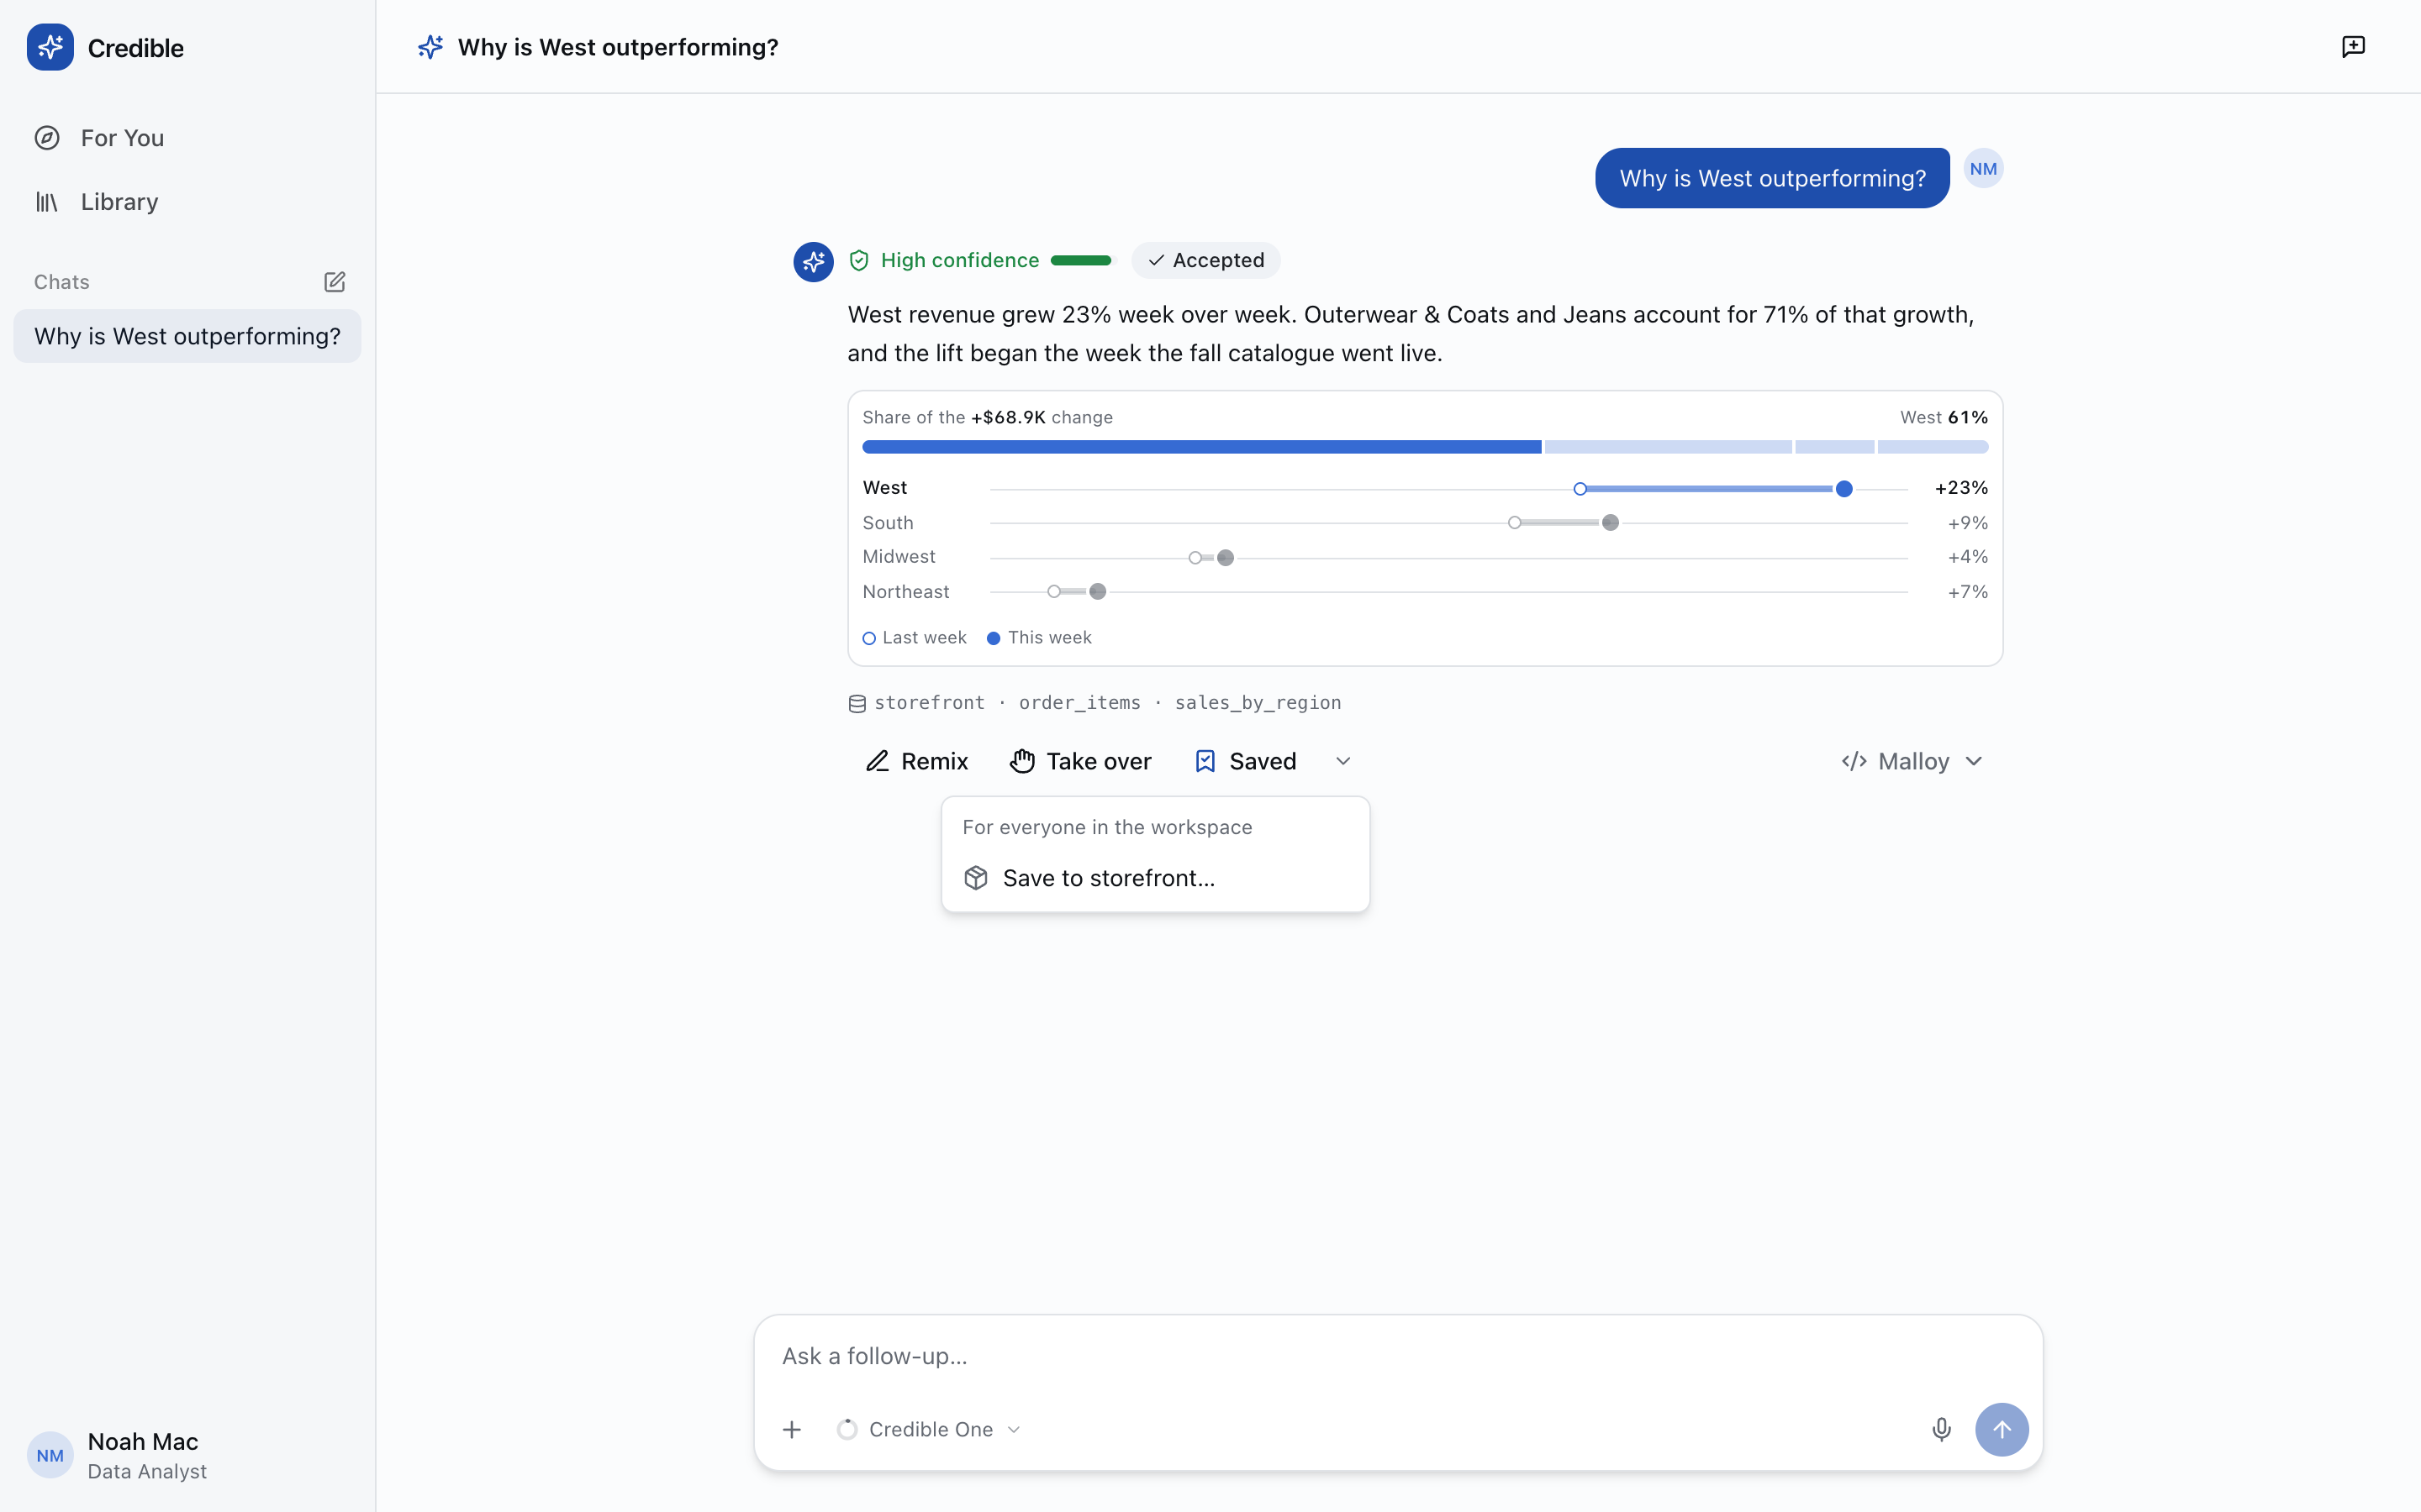
Two saves, one button. Save keeps it for you. The menu beside it, headed For everyone in the workspace, offers Save to storefront…, naming the package the data came from.
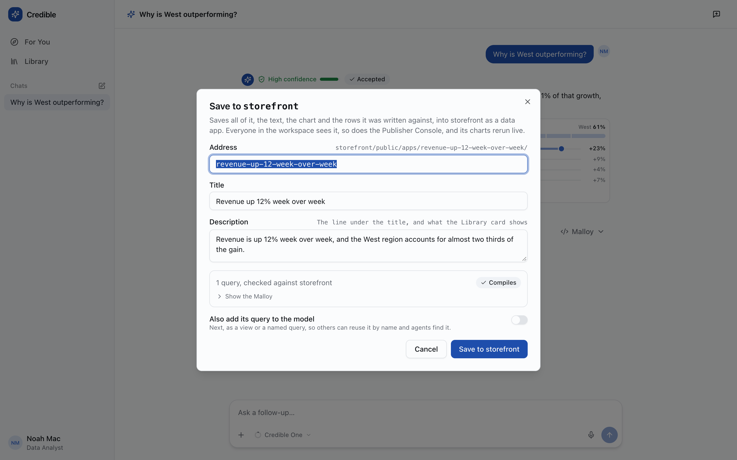
Save to a package. An address, title and description, and 1 query, checked against storefront — Compiles. Publisher compiles every query in the package before it writes anything, so a finding can only be saved where its data lives.
"Save to the workspace" now means writing the finding into the package as the manifest-backed data app described in Part 1: the claim, the details, the evidence chart, the queries, and a snapshot of the rows, written through PUT …/data-apps/{slug} with the same compile-first, hash-checked, rollback rules as the dashboard write. Once saved, it is the same object in both places. The Console lists it under the package, an agent finds it with get_context, and it's reviewed and versioned with the model. The toggle at the bottom continues into the promote wizard, which can also add the query to the model as a named view: or query:.
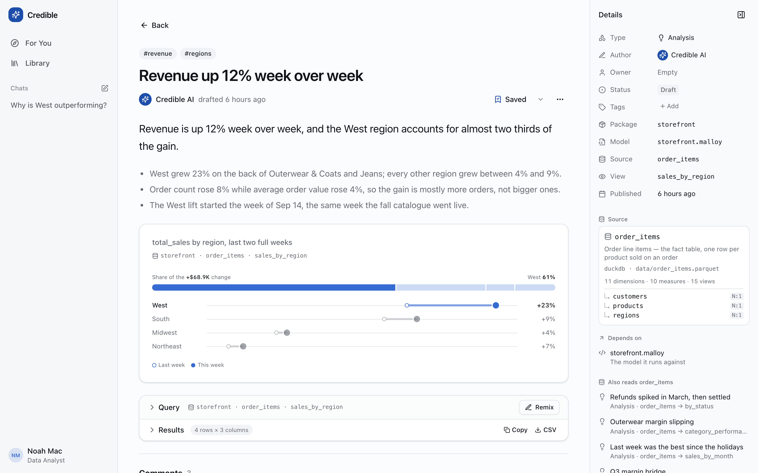
An analysis, once kept. The narrative and the details behind it, the evidence chart, the query and its rows (copy or CSV), and the details rail: author, owner, status, package, model, source and view. Below it, the source's card with its joins, then what it depends on and what else reads the same source. /analysis/an-revenue-west
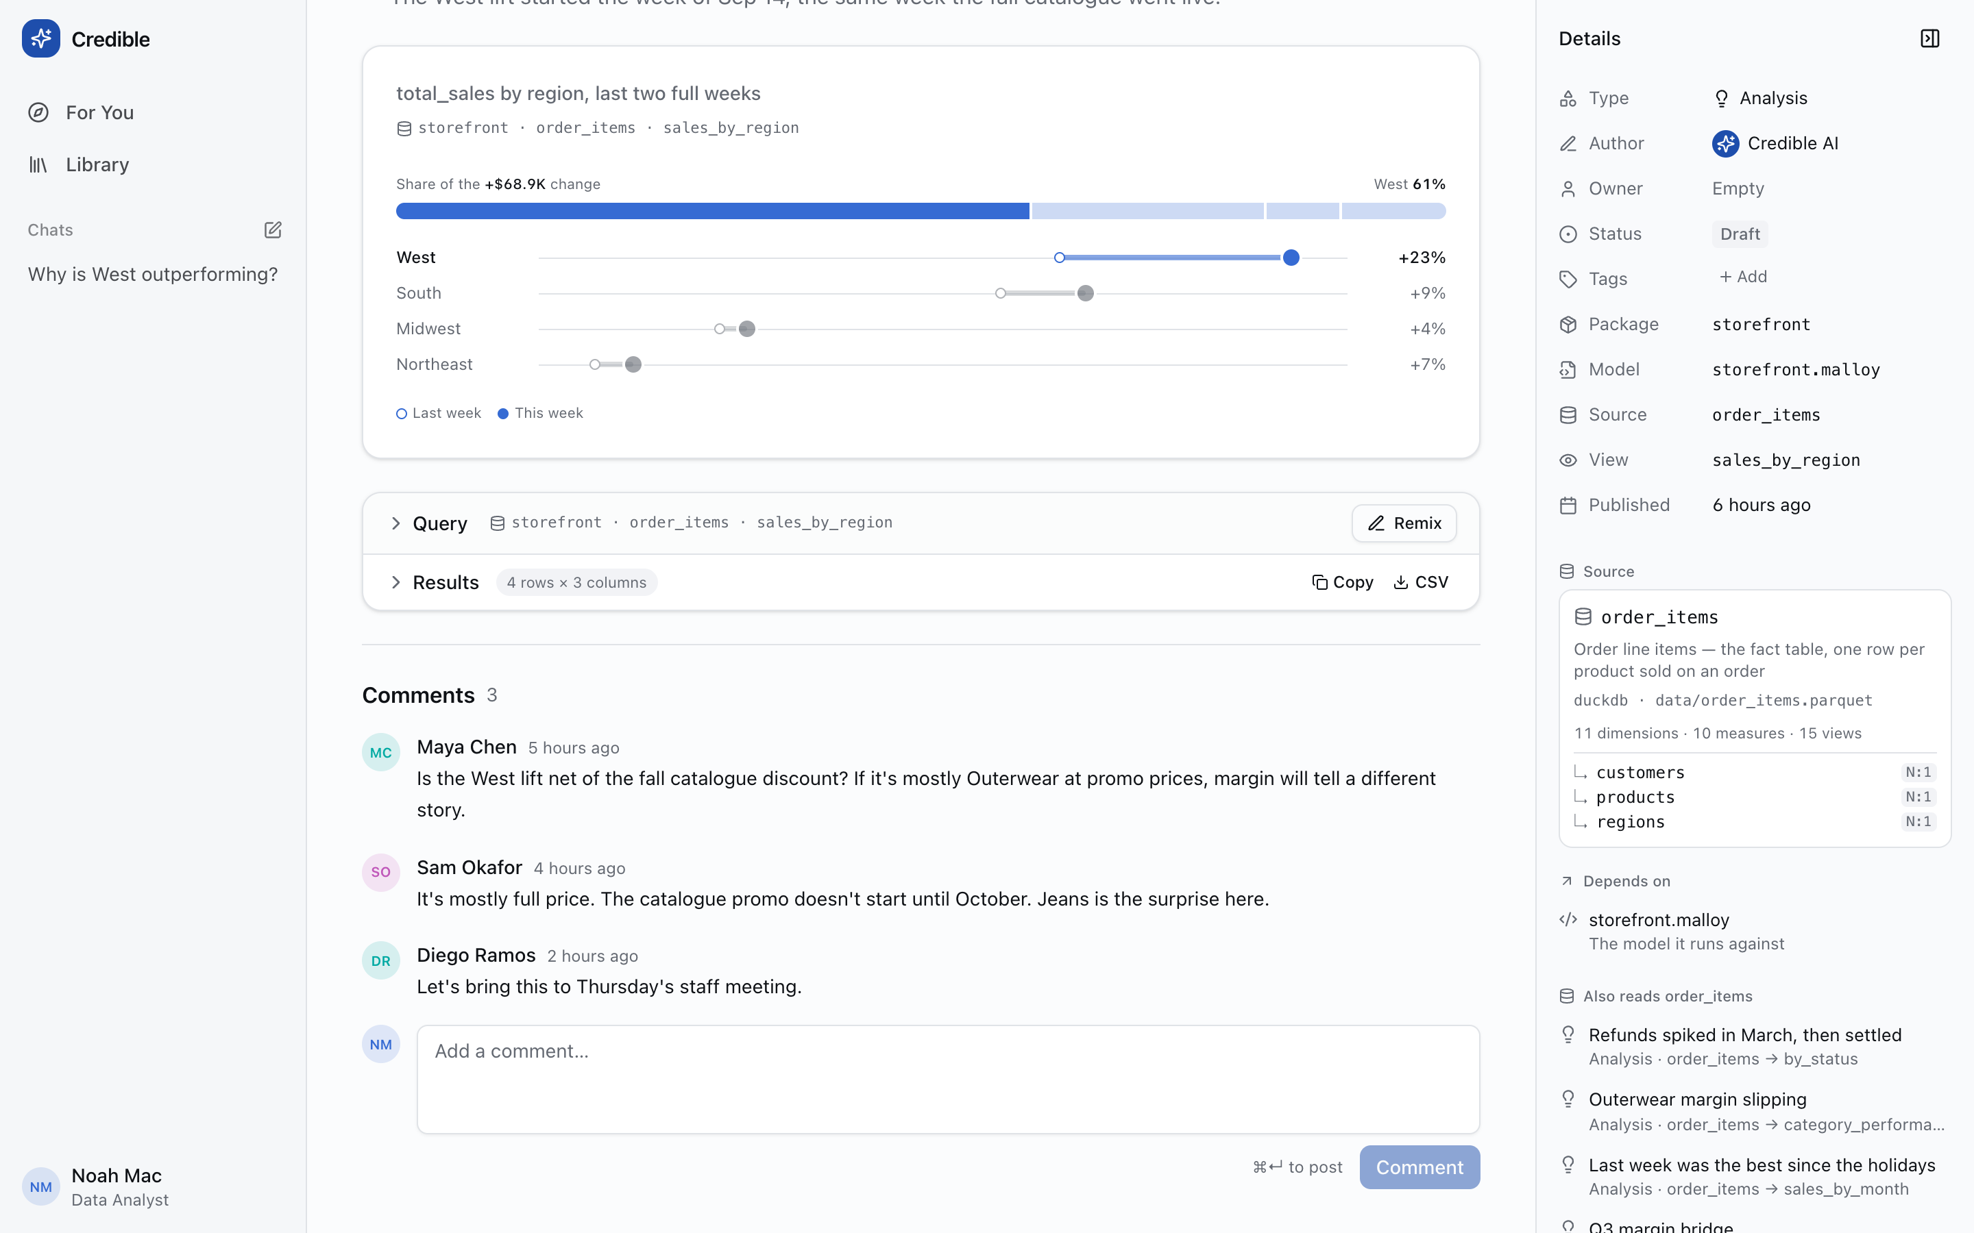
The discussion stays with the finding. When a finding is saved into its package, its comments go with it, so the conversation isn't left behind in someone's Library.

06 Making it yours: themes and white-labeling
The destination is meant to look like its owner's product, not like ours.
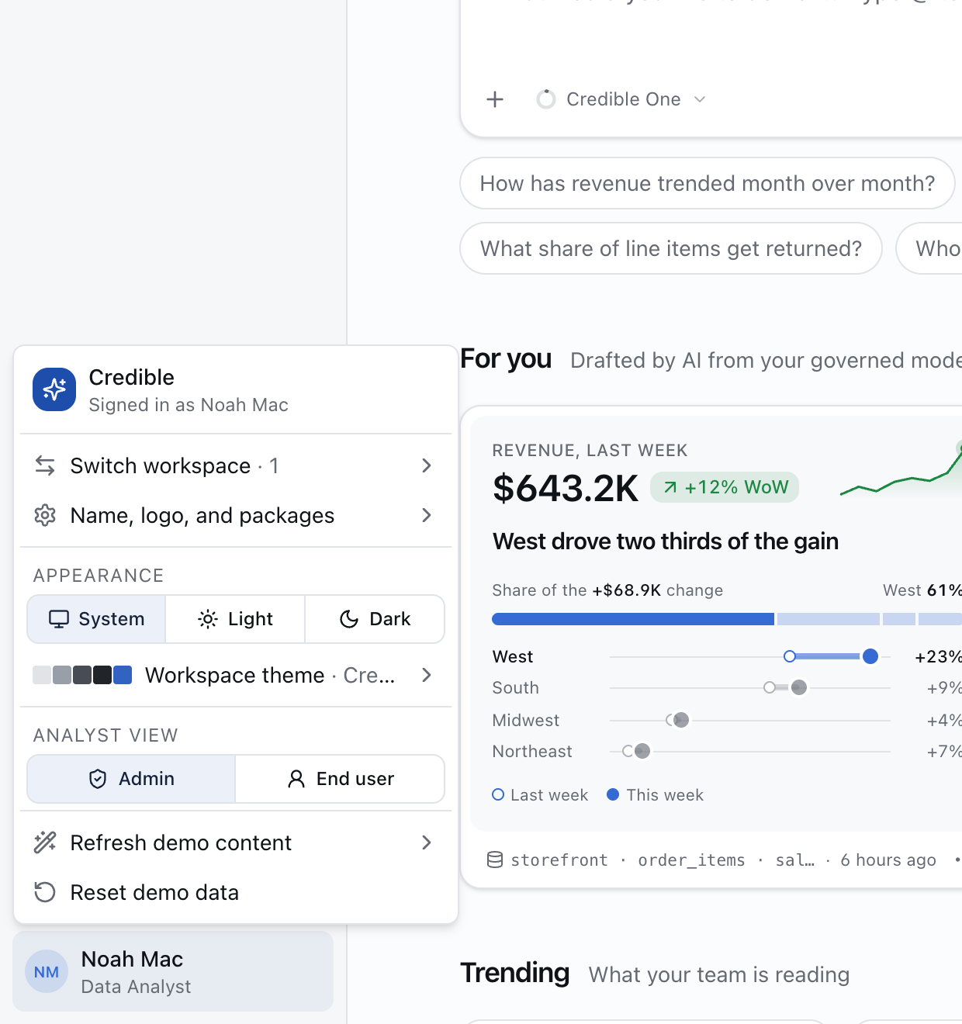
Everything lives in one menu. Switch workspace; set the name, logo and packages; choose System, Light or Dark; pick the workspace theme; and choose who the analyst treats you as (an Admin sees the trace, an End user doesn't).
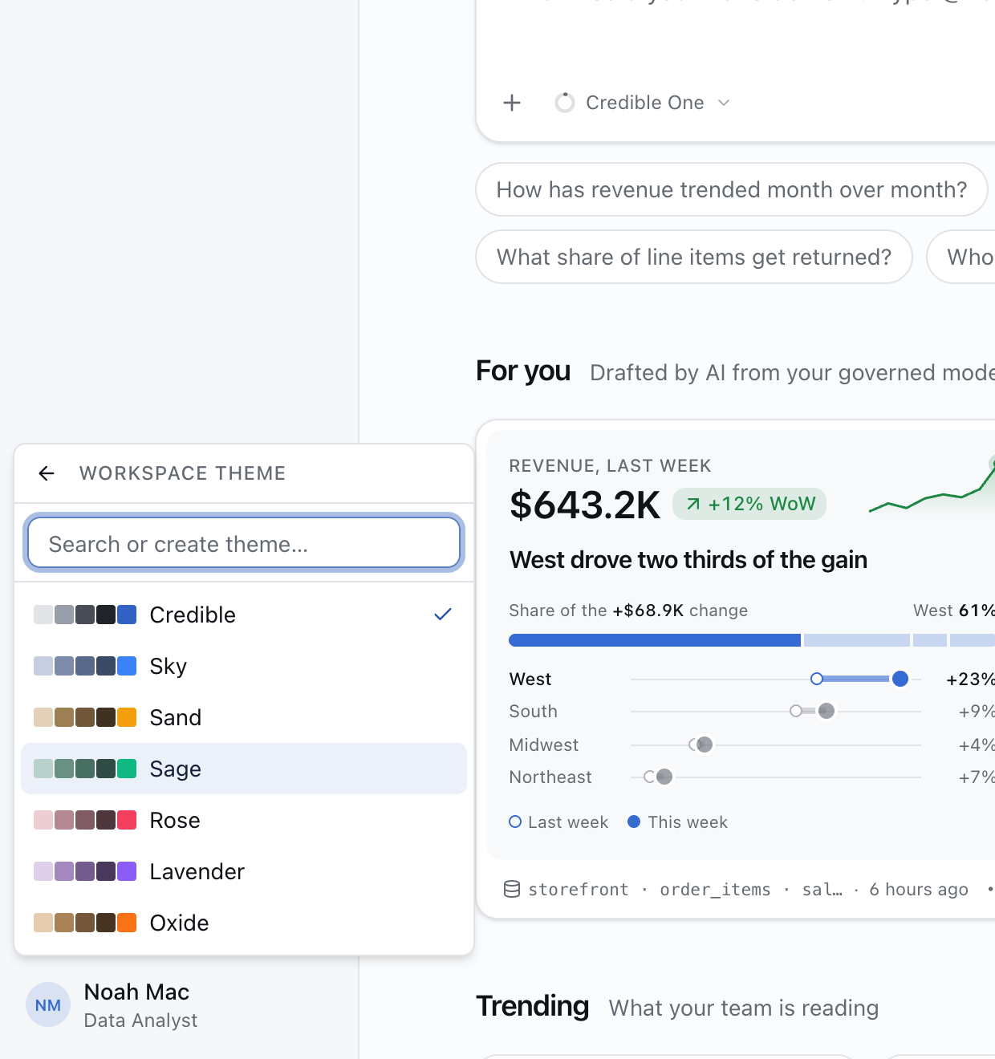
Workspace theme. Seven built-in themes, each a surface gray ramp paired with an accent. Type a name to create your own from any surface and accent.
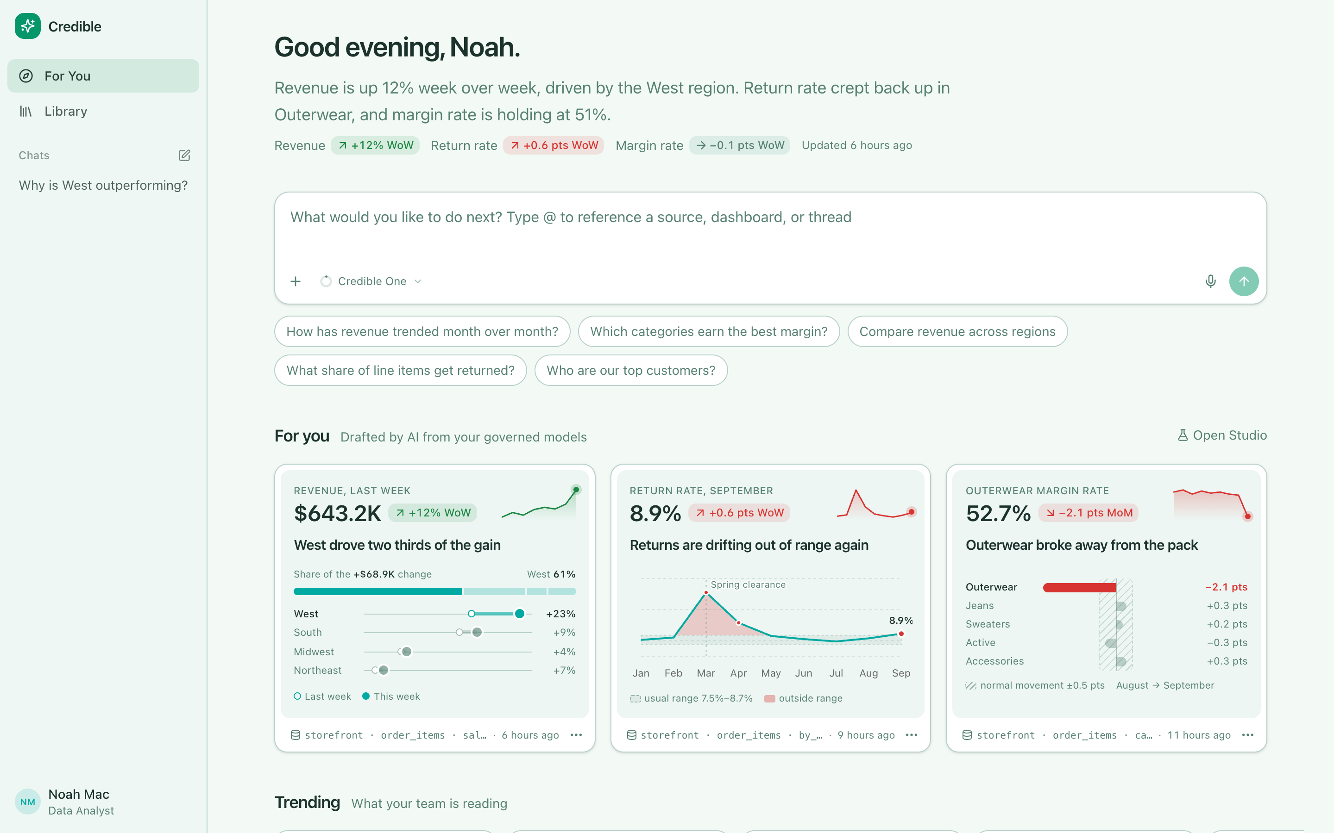
Sage, light.
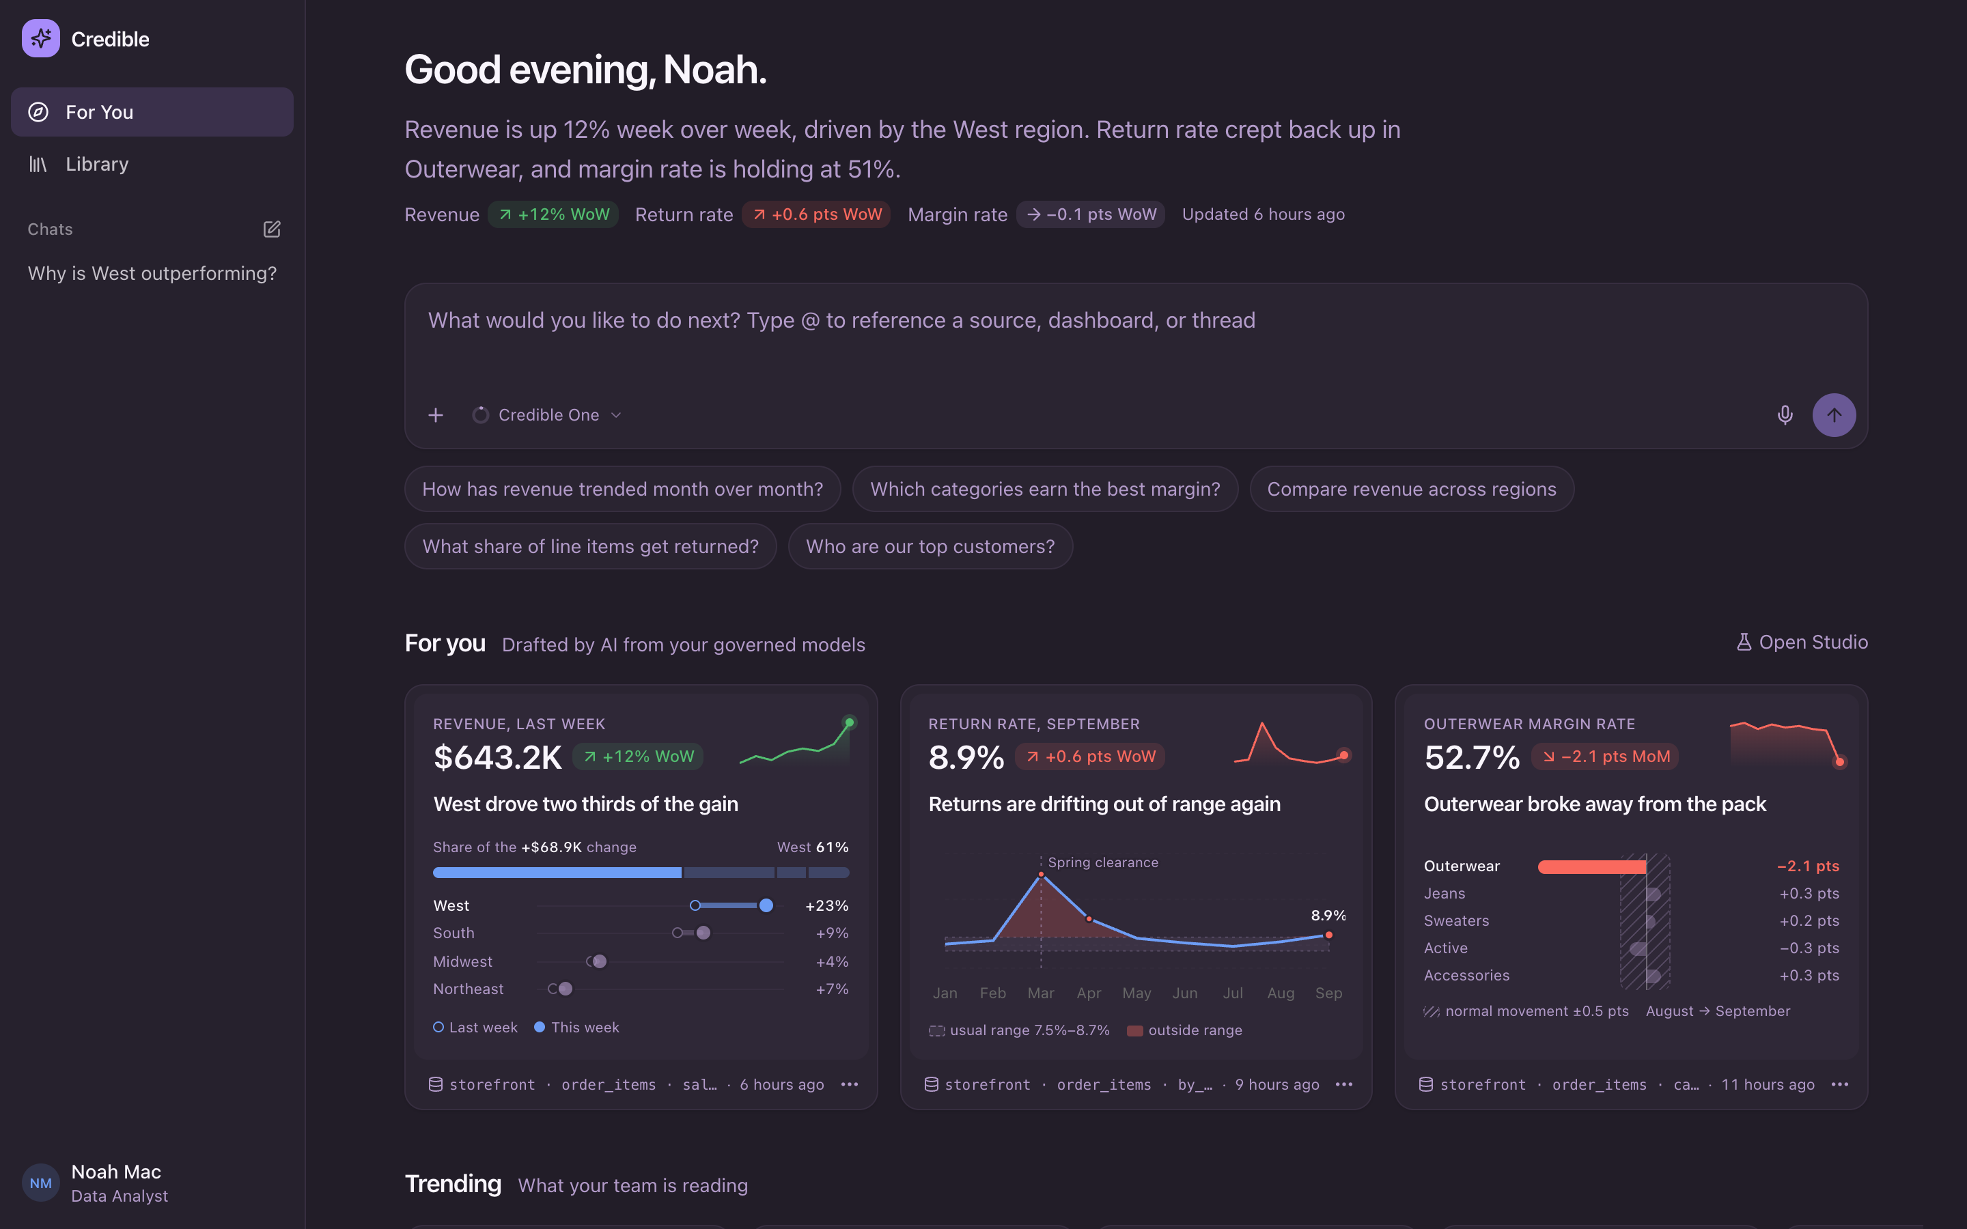
Lavender, dark.
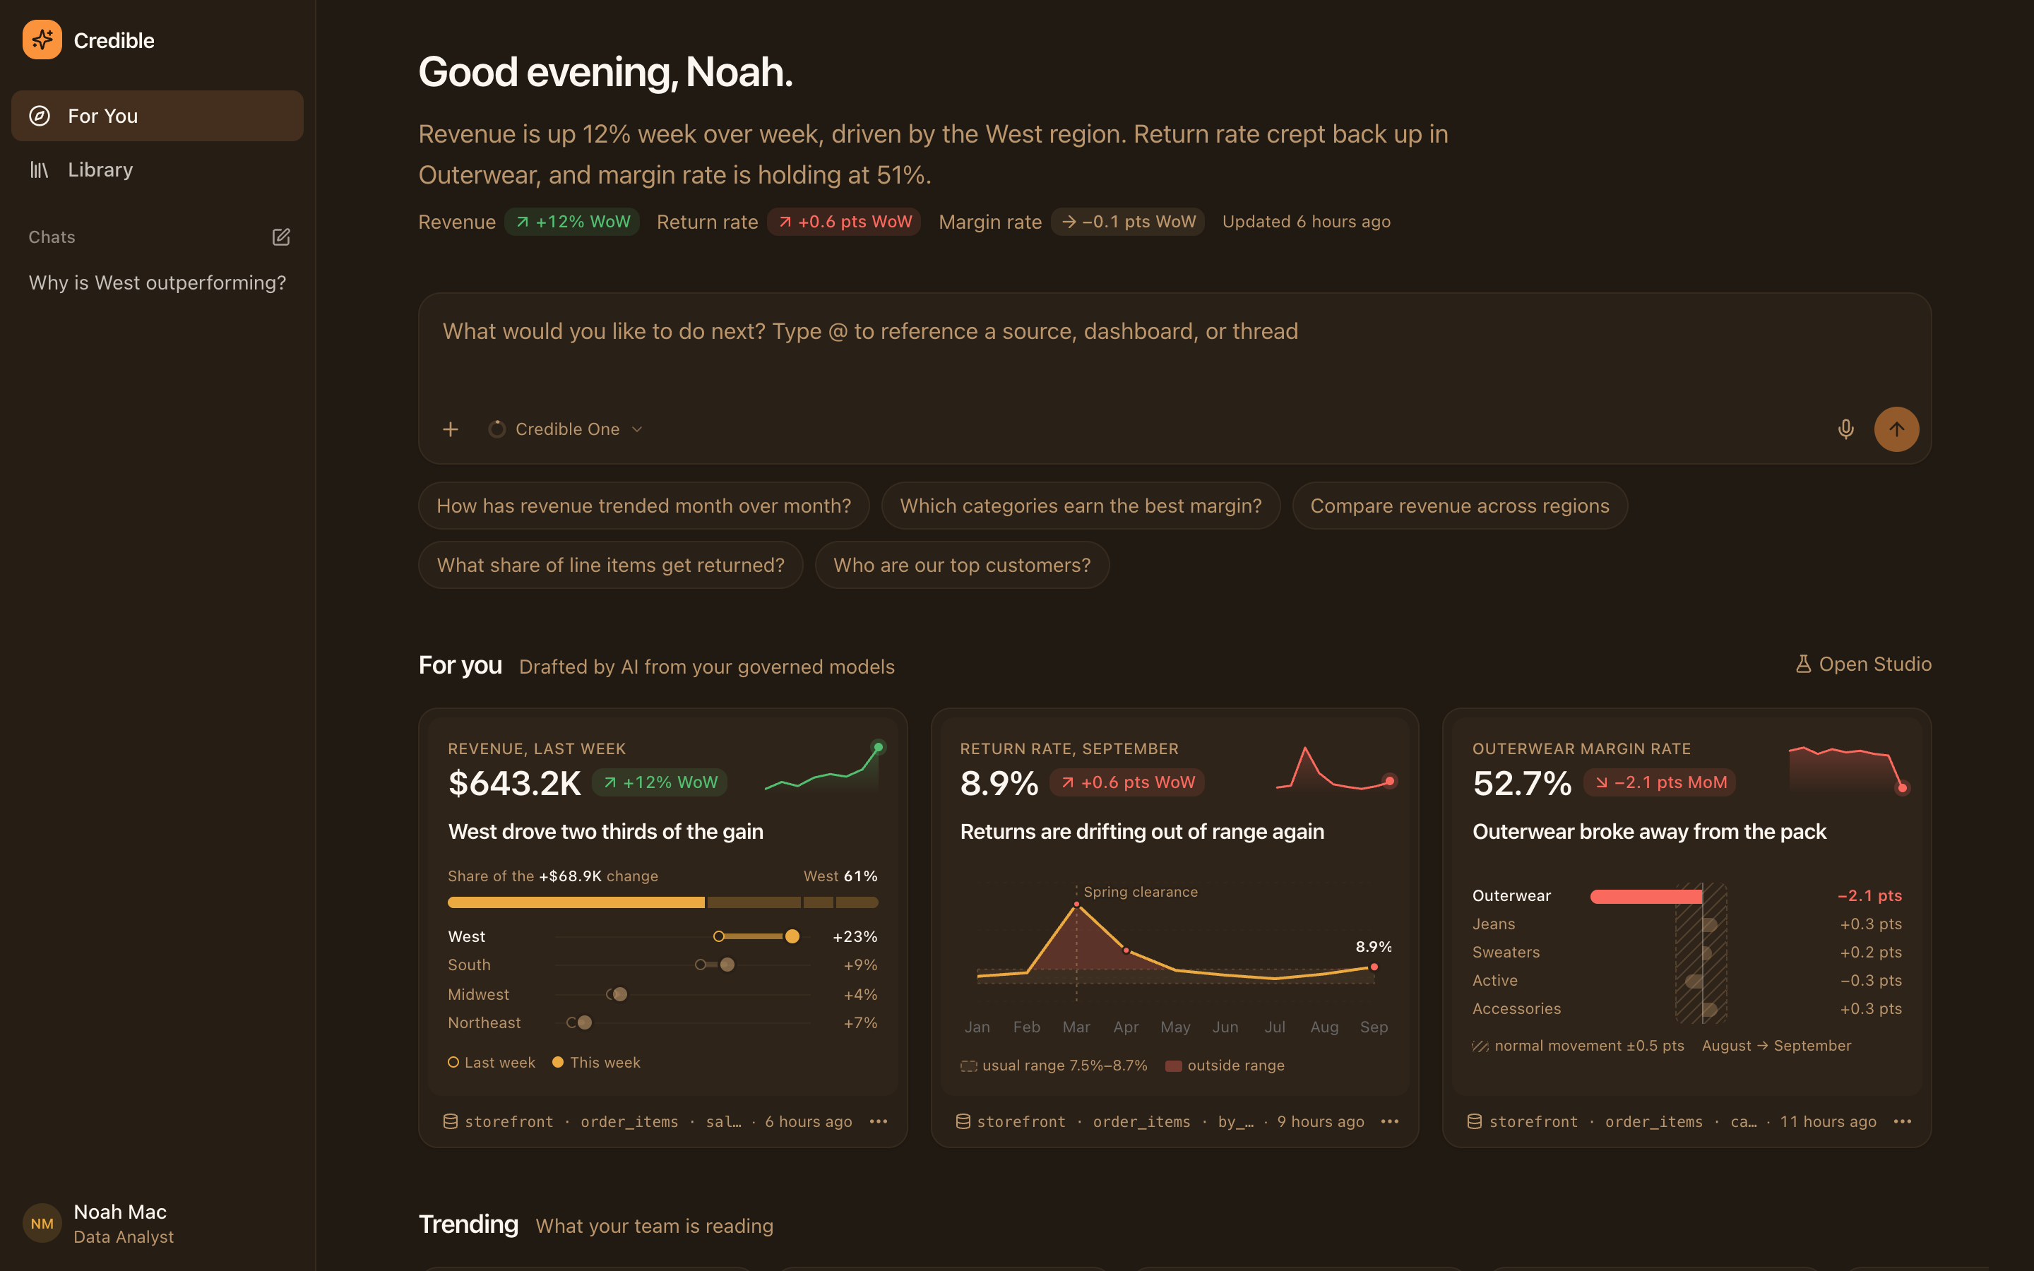
Oxide, dark.

How the theming holds together
- Two independent axes. Mode (system, light or dark) is personal. The theme belongs to the workspace. Custom themes are shared across workspaces.
- Every token is derived, not hand-picked. From one 11-step gray ramp and one 4-step accent, lib/theme.ts writes every shadcn token for both modes: background, card, muted, border, ring, primary, and the five sidebar tokens. Dark surfaces are made by lifting the theme's dark background toward a mid-tone of its own ramp with color-mix(in oklab, …), because ramps differ in how dark their low end is. So every utility class, including bg-chart-2/15, follows the theme with no per-component work.
- Charts follow the accent. The five chart colors stay the same, but their order rotates so the series nearest the accent's hue comes first, keeping the adjacency the palette was designed around. Renderers that can't read oklch() (Vega) get hex.
- Embedded content matches. useDataAppTheme() reads the computed tokens off the document and passes them to every embedded Publisher dashboard and data app as a DataAppTheme. The dashboard thumbnails in the white-label shot below are Publisher content, drawn in the workspace's colors.
- The default writes nothing. The Credible theme keeps the hand-tuned tokens in index.css. Other themes override them with doubled selectors (:root:root), so stylesheet order never matters.

White-labeling
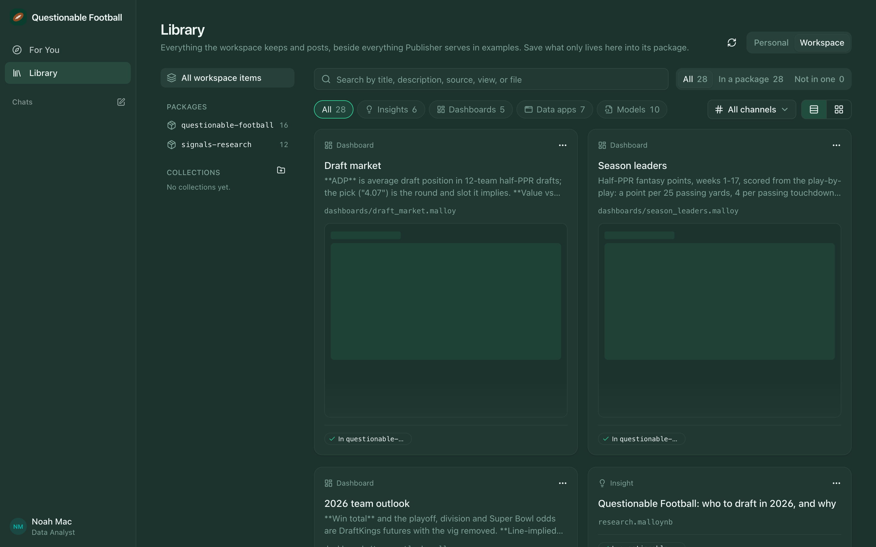
The same app, as Questionable Football. The workspace has its own name and logo in the sidebar, the Sage theme in dark mode, and is scoped to two packages, so the Library holds 28 items from questionable-football and signals-research and nothing else. The embedded dashboards are themed too.
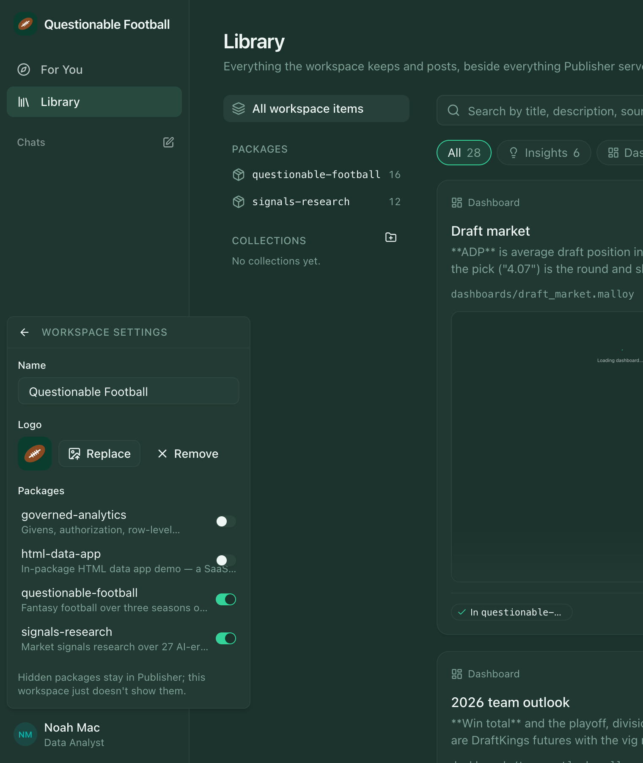
Name, logo, and packages. A raster logo is scaled to 128 px and stored as a data URL; an SVG is kept as it is. Hidden packages stay in Publisher; this workspace just doesn't show them. Each workspace also has its own content and theme, so one demo can be prepared without disturbing another.
Editor: Decide how far white-labeling should go: custom domain, favicon, font, email sender, "Credible AI" as the author name. Today it's the name, logo, theme and package scope.

07 The composer: point at the thing you mean
Questions about data go wrong when the question is vague about what it's about. In the composer, you type @ and name the exact entity.
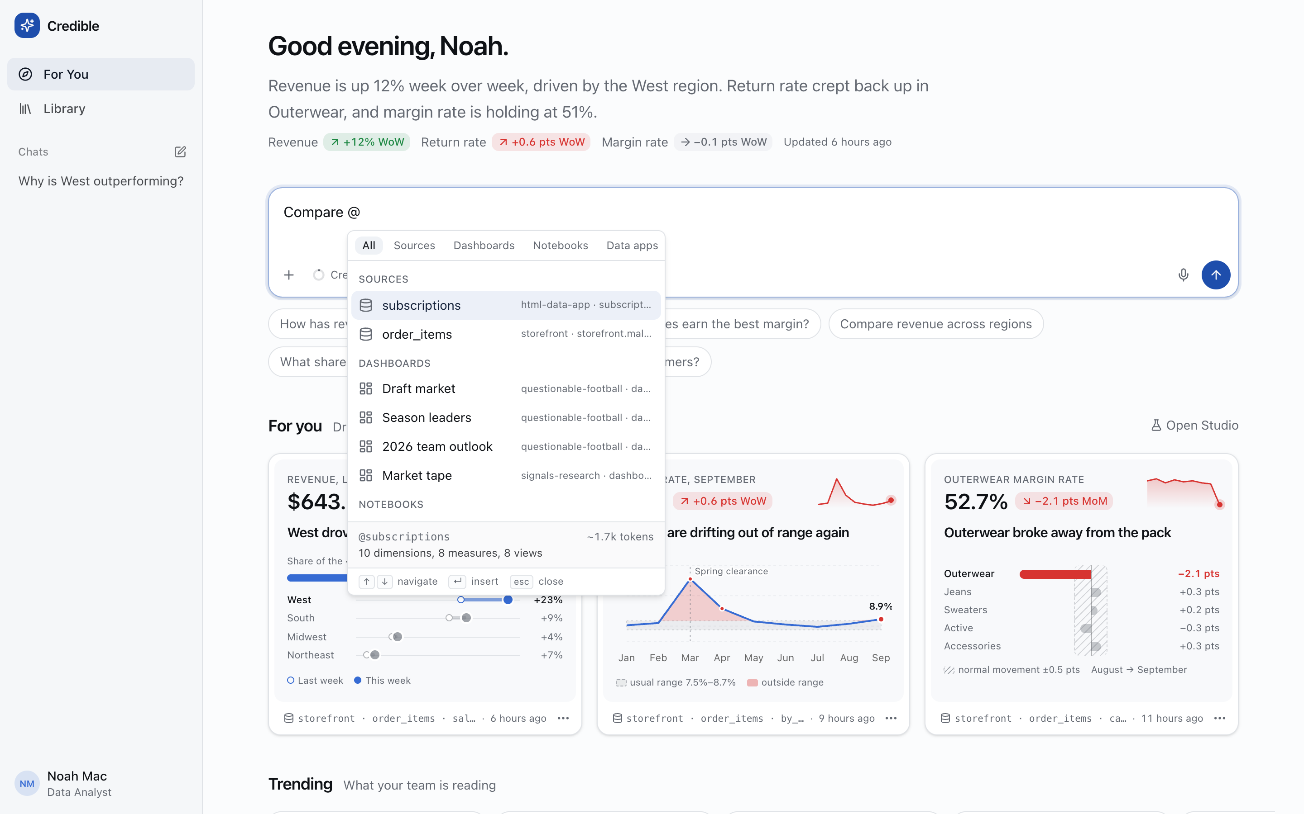
Type @. Every entity in the workspace, grouped and tabbed by kind. Each one shows its package and path, a summary (10 dimensions, 8 measures, 8 views), and what it would cost in context (~1.7k tokens).
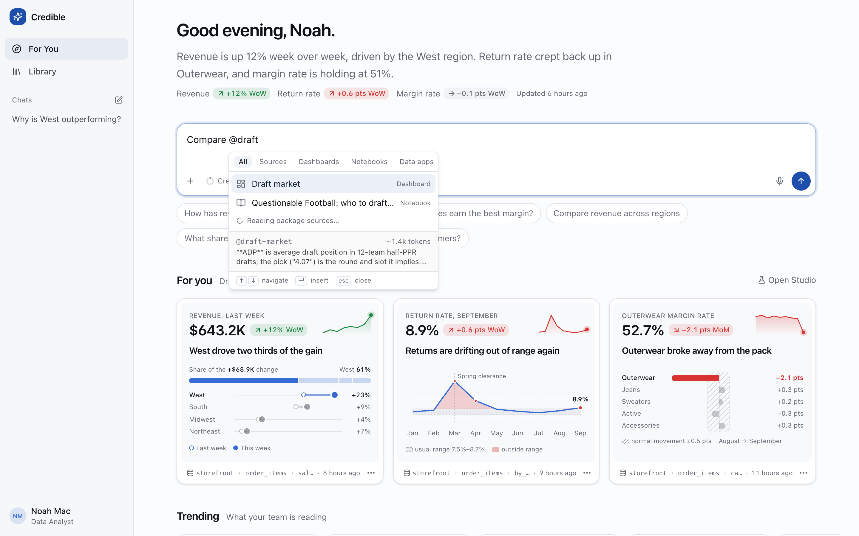
Keep typing to narrow it. @draft finds the Draft market dashboard and the notebook that mentions it, while package sources are still being read in the background.
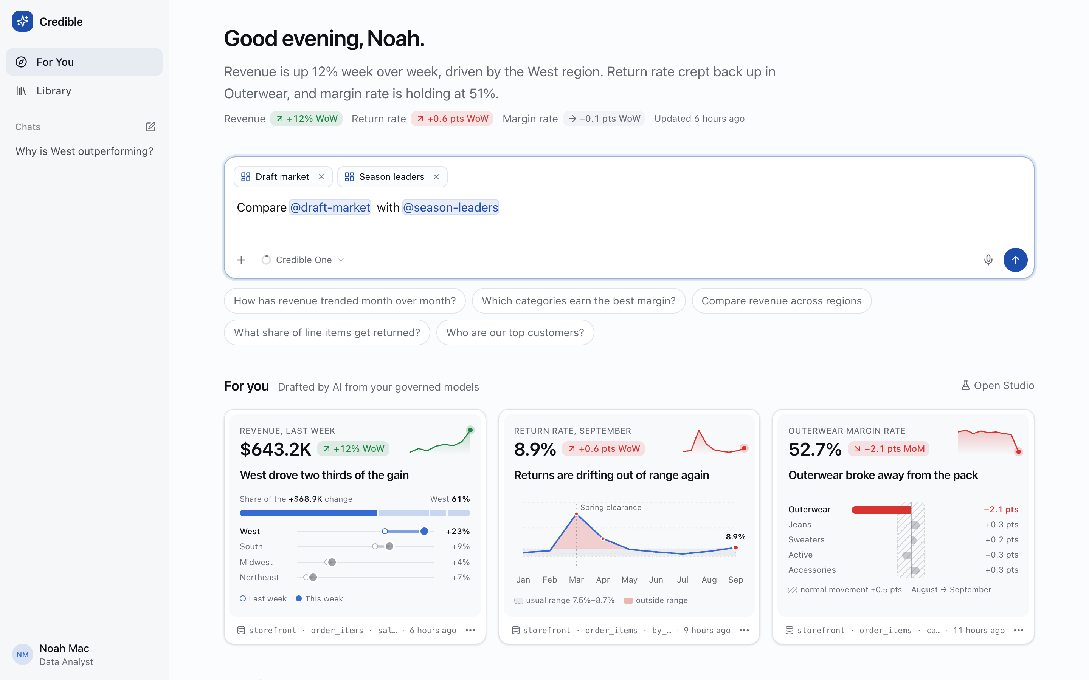
Mentions become chips. @draft-market and @season-leaders are placed inline and pinned above the input, so you can see exactly what goes with the message.
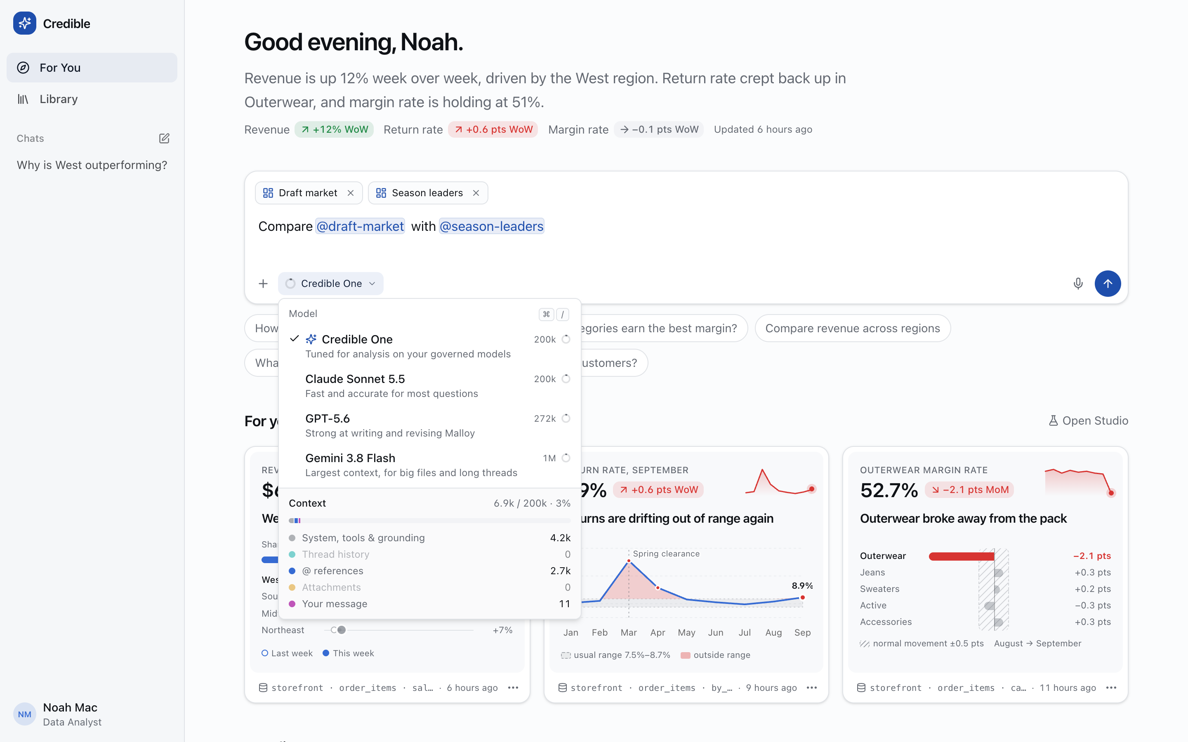
The context budget. The model picker (Credible One, Claude Sonnet 5.5, GPT-5.6, Gemini 3.8 Flash) breaks down what the message will cost: system, tools and grounding 4.2k, @ references 2.7k, your message 11, out of 200k.
Eight kinds of entity can be mentioned: sources, dashboards, notebooks, data apps, models, packages, and this app's own analyses and threads. Handles are unique per workspace, prefixed with the package when two collide. A mention sends the entity's definition to the analyst, and also tells the analyst what the answer should be grounded in, which is more useful. The composer also takes attachments and voice input.

08 Where it goes next
Every part of the loop exists in some form today. The next step is to connect the parts so each one learns from the others.
- 1 · Curate: What the workspace values — Featured and dismissed insights, saves, follows, collections, comments, channels, and what people open and for how long.
- 2 · Steer: Recipes that learn — Those signals become the Studio's steer, detectors and sources, per person and per workspace, instead of a fixed daily recipe.
- 3 · Explore (future): Autonomous analysis — Runs that follow up on their own findings: a change leads to a driver, then a segment, then a comparison against last year.
- 4 · Propose (future): Semantic exploration — Walk the model's graph, then propose the dimension, measure, join or #(doc) that would have made a finding easier to reach.
↺ what people do with step 4's proposals feeds back into step 1

Autonomous insight generation (next)
- Chains, not single facts. Today one press gives one insight. Next, a run follows up on what it found, a change to its driver and then to its segment, and presents the chain as one argument with every link grounded.
- More detectors. The four kinds today are change, anomaly, mix shift and driver. Next: cohorts, forecast misses, threshold crossings defined by givens, and "a saved finding has gone stale."
- Findings that check themselves. A saved finding keeps the rows it was written against. Re-running it on schedule and flagging when the live chart disagrees with the prose is cheap and very valuable. The put/call finding in Part 1 is the case for it.

Autonomous semantic and ontological exploration (later)
- Read the model as a graph. Sources, joins, views, givens, and the relations the details rail already draws are an ontology of the business. An explorer can walk it to find gaps: measures that nothing reads, joins that fan out, dimensions with no #(doc), questions in chat that missed because a field didn't exist.
- Propose, don't write. Output is a proposed model edit with a probe receipt for every claim, reviewed like code. The eval-diagnose and eval-improve skills already do this for eval failures. This aims them at the workspace's own questions.
- Model as you go. When a chat answer rests on a judgment call (what counts as "active", which date "revenue" is booked on), the destination offers to write that judgment into the model, so the next answer doesn't have to make it again.

The recommendation loop (next)
- Preferences that are curated, not inferred. A workspace admin's features and channels set the default, a person's follows and dismissals adjust it, and both can be inspected and edited. "Why am I seeing this?" should be one click.
- Signals today: seen this session, dismissed (with undo), featured, saved, topics, source and view. Missing: persistence across sessions, reading time, which channels people actually open, and outcomes, such as a finding brought to a meeting.
- The relatedness score (shared topics, same source, same view) becomes a learned weight per workspace, but stays a sentence a reader can follow: "Related to #revenue and #regions, because you read West's lift."

Platform work under all of it (now)
- Move Library state (items, threads, comments, collections, preferences) out of localStorage into a store that Publisher, or the host, owns.
- Identity and permissions: carry givens and #(authorize) through from the signed-in person, so For you never drafts an insight a reader couldn't query.
- Make the Studio's schedule a real job, sharing Publisher's materialization scheduler.
Editor: Pick the one bet for next quarter. My vote is self-checking findings plus the recommendation loop, because both build on parts that already work.

09 Status
Piece | State
Destination app (packages/destination) | Uncommitted prototype, about 28k lines of TypeScript. Publisher content is read live; Library, threads and comments are fixtures in localStorage.
Analyst Worker (chat and Studio generation) | Live over OpenRouter with a key; scripted planner without one. MCP surface credible-analyst.
Console Publish button and SDK PublishProvider | Uncommitted; shown only when a destination URL is configured.
Save to a package (data apps) | Phases 1–4 of library-data-apps-plan.md are in the tree: manifest schema, renderer, the …/data-apps/{slug} endpoints, and the Save menu and dialog. Phase 5 has not started.
Themes, workspaces, white-labeling | Working; stored per browser. Needs server-side workspace settings to be shareable.

Reproducing the screenshots
Run Publisher (bun run start), the dev Console (bun run start:dev:react) and the destination (cd packages/destination && bun run dev, on :5180). Then run node docs/unboxing/capture-destination.mjs for the plain routes and node docs/unboxing/capture-destination-flows.mjs [flow …] for the interactive ones. The flows are library, chat, analysis, composer, menus, themes, studio, publish and whitelabel. Each runs in a fresh browser context, so your own themes and workspaces are untouched.

Previously: ← Part 1 of 2 — Unboxing Publisher, from two packages I already knew
The two example packages this Library is full of, questionable-football and signals-research, what building them taught about Publisher, and the Question mode whose result is published in section 03.
Publisher teardown · Part 2 of 2 · Noah · draft, Sep 30, 2026

